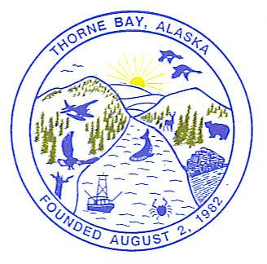

**NOTICE OF CANVASS MEETING**

##### SPECIAL MEETING

**CITY OF THORNE BAY , ALASKA**

**THIS IS TO NOTIFY ANY INTERESTED PERSONS** that on **FRIDAY**, the **10TH** day of **October 2025**, at **5:00 p.m**., the Thorne Bay City Council will hold a Special Meeting to canvass all absentee, questioned and defective ballots received in the Regular Municipal election. If the council is unable to obtain a quorum, or complete the count on Friday, after the election, the canvass will be continued the following day and each day thereafter until complete.

**Canvassing of Absentee Ballots October 10th**

5:00 PM - 6:00 PM Friday, Oct 10, 2025

**Meeting link:**

<https://cityofthornebay.my.webex.com/cityofthornebay.my/j.php?MTID=m353ab94cf049e32cb1e748c78431d4ee>

Meeting Number: 2550 588 8695

Password: 3380

Agenda: The City Council will count all absentee ballots cast for the Regular Municipal Election held October 7th, 2025, beginning at 5pm.

## **More ways to join**

**Join by video system**

Dial 25505888695@webex.com

You can also dial 173.243.2.68 and enter your meeting number.

**Join by phone**

+1-650-479-3208 United States Toll

Access code: 2550 588 8695