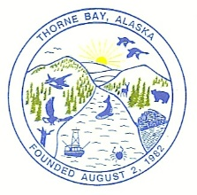
CITY OF THORNE BAY

PUBLIC NOTICE

Summer Parks Maintenance Employee

TEMPORARY EMPLOYEE

The City of Thorne Bay is accepting applications for a temporary employee.

Applicants will be assisting in the Parks and Recreation maintenance and at times assisting City Staff in other areas under the direction of the Harbormaster/Parks & Rec Supervisor.

Applicants must be at least 16 years of age. For those under 18 years of age a work release must be signed by parent or guardian. Applications may be picked up at City Hall. Position open until filled.

Pay will be $20.43 (Grade 5 Step 1 on the 2023 GS Pay scale). Workdays will be Monday through Friday with possibly an occasional weekend. Hours will be variable depending on weather, projects, and applicant’s availability. High school students are encouraged to apply.

Open until Filled.

