MINUTES
FOR THE REGULAR MEETING
OF THE CITY COUNCIL FOR THE
CITY OF THORNE BAY, ALASKA
TUESDAY, February 7, 2023
TIME: 6: 30 p.m.

THERE WAS A WORKSHOP THAT BEGAN AT 6:00PM

- CALL TO ORDER:
Mayor Burger called the meeting to order at 6:30 pm

- PLEDGE TO FLAG:
The council and audience stood for the pledge to the flag.

- ROLL CALL:
Oatman, Jennings, Stram, LaVoie, Hartwell, Burger and Nyquest were present.

- APPROVAL OF AGENDA:

Burger moved to approve the agenda. Hartwell seconded the motion. There was no further discussion.

MOTION: Move to approve the agenda.
F/S: Burger/Hartwell
YEAS: Hartwell, Jennings, LaVoie, Burger, Nyquest, Oatman & Stram
NAYS: None
STATUS: Motion Passed.

MAYOR’S REPORT:
Mayor Burger commented on the poor telephone services within Thorne Bay.

ADMINISTRATIVE REPORTS:
    - City Administrator:
- In the process of hiring a new Assistant Solid Waste Operator so far there are a total of 6 applicants and will likely interview all six applicants.
- Currently working on a one-time Asbestos Disposal Permit for the hazardous materials clean-up and demolition of the old fire hall.
- Working on grant application with OVK and their consultant for the Kasaan Road.
Currently at the end of working on a Community Transportation Grant for the Kasaan Road through Department of Transportation.
- Working on closing out CDBG Grant for Davidson Landing Fire/EMS Hall.
- Working on a reimbursement request for the Kasaan Road intersection project to the Forest Service for payment of the work done to date.
- We did get the Port to Claw Trail grant closed out and got reimbursed by the Forest Service prior to the deadline.
- We are getting estimates for the Solid Waste Baler Building repairs and expect them to be in the neighborhood of $40,000. I will bring a recommendation to the next meeting for repairs once I have them and can see what the insurance company will pay for the one door, expected to be $12-$14K for that repair.
- Report from Superior Marine on the EMS boat is that it looks repairable and will be fixed before March.

Oatman inquired why there was a limit of 19 years of age in order to work at Solid Waste. Huestis commented that he was not sure of a reason, it could have been an oversight and if there was nothing that prohibited it, an 18-year-old would be considered.
Nyquest expressed concern of the City hiring people and then paying for them to get their CDL and they quit for higher paying jobs. Suggested the City offer current employees get their CDL. Huestis commented that all employees are encouraged to get their CDL, but none are interested.

  - Department Reports:
      - Water Department Report:
Sam Sawyer, Water & Wastewater Supervisor
Currently we are working with Village Safe water on getting grant funding to overhaul our sewer lift stations, electrical panels and replacing/repairing sewer manholes.
We have identified the main sources of ground water infiltration in our distribution system and worked closely with Village Safe Water to determine the most important issues needing to be addressed.

Conclusions and Recommendations:
The community of Thorne Bay has been struggling with I&I entering their wastewater system for many years, so these proposed improvements are essential for long-term operation and compliance of their system. Approximately 40 manholes need to be completely reconstructed and built up appropriately to the grade of the road, while another 70 can be improved by grout sealing the cracks and joints. Four of their five lift stations need desperate rehabilitation. This includes Mechanical Systems, Ductile iron discharge piping, Ball style check valves, new pumps, Electrical Systems, New electrical switchgears, Exterior wet well junction boxes, Cable plugs, Control Systems, Headend SCADA computer, Primary and backup level sensors, Standardized control panels. All these improvements are vital in aiding the community to maintain compliance with their wastewater discharge permit, reduce O&M and electrical costs, and establish a system that will address the community’s needs for decades to come.

      - Harbor Report:
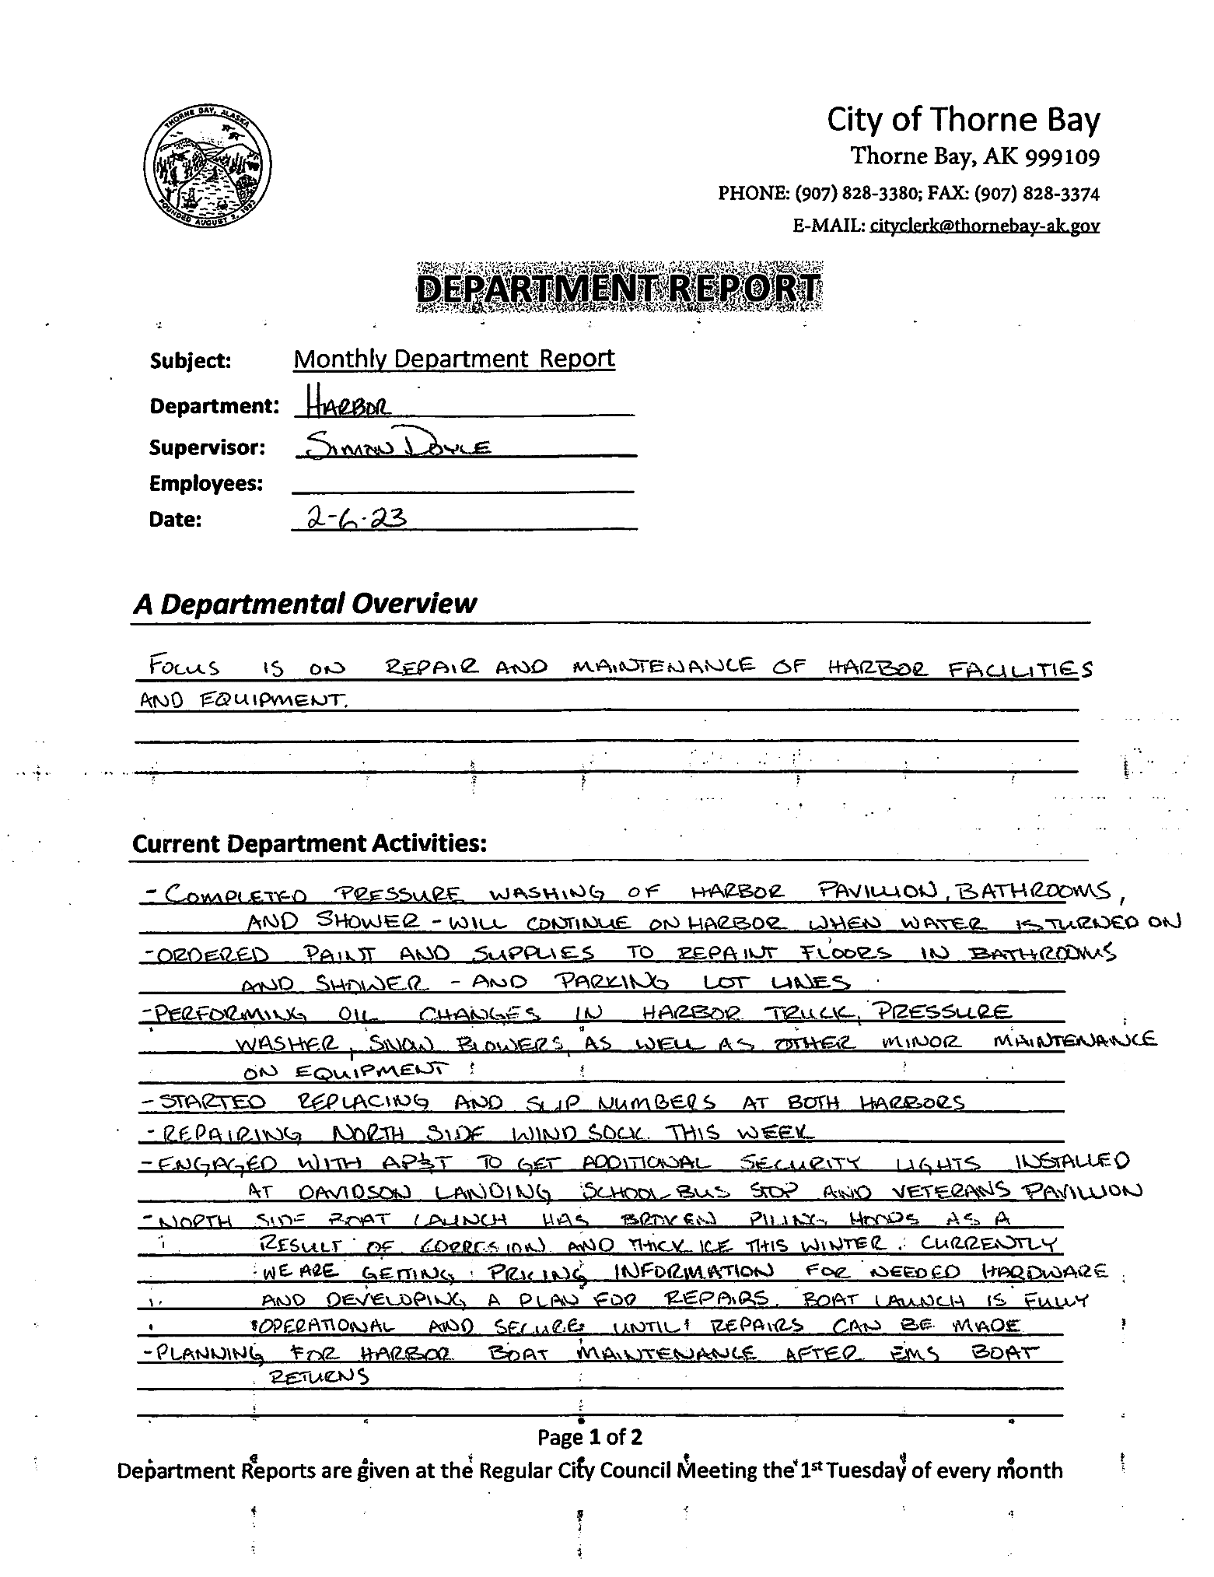
Simon Doyle, Harbormaster, reported the following:

PUBLIC COMMENTS:

Anthony Lovel commented on the following:
- EMS board meeting was held and elected officers to qualify for their non-profit corporation status.
- The Sponsoring physician will be on the Island to do the Skills Training for the EMT’s
- Working on Grants for radios and a new ambulance
- Update from previous EMS report, over the 2022 year there were 38 calls

Samuel Sawyer commented on the following:
- If the city is willing to pay for a new employee to get a CDL, are they willing to pay existing employees? Huestis stated that all employees are encouraged. Sawyer commented he was not aware.
- Suggested the City put a clause into the hiring that if the city pays for someone to get their CDL that they must pay it back.

COUNCIL COMMENTS:
There were no council comments.

CONSENT AGENDA:
  - MINUTES
    - Minutes of the January 17, 2023, Regular City Council Meeting, discussion and action item:

Burger moved to approve the Consent Agenda consisting of the Minutes for the January 17, 2023, City Council Meeting. Hartwell seconded the motion.

MOTION: Move to approve the Consent Agenda consisting of the Minutes for the January 17, 2023, City Council Meeting.
F/S: Burger/Hartwell
YEAS: Burger, Nyquest, LaVoie, Hartwell, Jennings, Oatman & Stram
NAYS: None
STATUS: Motion Passed.

- NEW BUSINESS:
  - Resolution 23-02-07-01, A Resolution of The City Council of Thorne Bay, Alaska, Updating the Authorized Signers On The Ems Checking And Savings Account With Tongass Federal Credit Union
Burger moved to approve Resolution 23-02-07-01 A Resolution of The City Council of Thorne Bay, Alaska, Updating the Authorized Signers On The Ems Checking And Savings Account With Tongass Federal Credit Union. Hartwell seconded the motion.

MOTION: Move to approve Resolution 23-02-07-01, A Resolution of The City Council of Thorne Bay, Alaska, Updating the Authorized Signers On The Ems Checking And Savings Account With Tongass Federal Credit Union
F/S: Burger/Hartwell
YEAS: Burger, Nyquest, LaVoie, Hartwell, Jennings, Oatman & Stram
NAYS: None
STATUS: Motion Passed.

  - Resolution 23-02-07-02, A Resolution Of Support For An Organized Village Of Kasaan Grant Application To The Alaska Department Of Transportation And Public Facilities Community Transportation Program For The Improvement Of The First 5.4 Miles Of The Kasaan Road
Burger moved to approve Resolution 23-02-07-02, A Resolution Of Support For An Organized Village Of Kasaan Grant Application To The Alaska Department Of Transportation And Public Facilities Community Transportation Program For The Improvement Of The First 5.4 Miles Of The Kasaan Road.
Hartwell seconded the motion.
Huestis explained the purpose of the Resolution was to support the CTP Grant application that the Organized Village of Kasaan is putting in for. This resolution would also support a one percent match of the overall grant amount.
Huestis commented that the difference of OVK applying for the grant instead of the City of Thorne Bay, is because we would be required to put forth a 9.03% match, which is not feasible for Thorne Bay to do.
Huestis commented that the cost for reconstructing the 5.4 miles of road is just under 15 million dollars. That section of road was selected because it is the section that would benefit the most from it.
With OVK applying for these funds, they are able to filter the grant through the State to the Tribe and allows them more control of the grant and keeps the costs down. Additionally, the State is extremely busy and is under a lot of pressure to distribute the money to all of these projects and with OVK able to take over and manage the project, it takes some of the workload off of them. This is not official but may be a factor. By adopting this resolution showing support for this road and offering funds towards a match, it will show this is a team effort which scores higher when determining a grant award.
Nyquest inquired if the City would be on the hook for the extra funds if the project went over by 5 million. Huestis commented that the Resolution is only authorizing up to $150,000.00.
Oatman inquired how long the city would have until they had to pay the $150,000.00? Huestis commented that it was hard to say, but likely at least 2 years. The City will make sure that we are saving up our Sales Tax account to be certain the funds were there when needed.

MOTION: Move to approve Resolution 23-02-07-02.
F/S: Burger/Hartwell
YEAS: Burger, Nyquest, LaVoie, Hartwell, Jennings, Oatman & Stram
NAYS: None
STATUS: Motion Passed.

  - Resolution 23-02-07-03, A Resolution Of The City Council, For The City Of Thorne Bay, Accepting A Bid And Authorizing A Budget For The Purchase Of Three New Garage Type Doors For The Solid Waste Bailer Building And Authorizing A Contract For The Repairs.

Burger moved to approve Resolution 23-02-07-03, A Resolution Of The City Council, For The City Of Thorne Bay, Accepting A Bid And Authorizing A Budget For The Purchase Of Three New Garage Type Doors For The Solid Waste Bailer Building And Authorizing A Contract For The Repairs. Hartwell seconded the motion. Huestis explained the need for the expense.

Huestis commented that he did not shop around for a bid to do the repairs but feels that the quote received is reasonable.

Nyquest inquired why the City didn’t file claims on other damages that were done to the building a well.
Huestis commented that he was sure they could have been claimed at the time but doesn’t think it could be reported this late.
Jennings inquired if this would make the city have to pay more in the long run, will the insurance rates increase? Huestis commented that the insurance company wants us to report damages. We participate in an Insurance Pool, so it doesn’t increase rates.

MOTION: Move to approve Resolution 23-02-07-03, A Resolution of The City Council, For The City Of Thorne Bay, Accepting A Bid And Authorizing A Budget For The Purchase Of Three New Garage Type Doors For The Solid Waste Bailer Building And Authorizing A Contract For The Repairs
F/S: Burger/Hartwell
YEAS: Burger, Nyquest, LaVoie, Hartwell, Jennings, Oatman & Stram
NAYS: None
STATUS: Motion Passed.

- ORDINANCES FOR PUBLIC HEARING: There were no ordinances for Public Hearing.
- ORDINANCES FOR INTRODUCTION: There were no ordinances for introduction.

- CONTINUATION OF PUBLIC COMMENT:

Anthony Lovel commented on the following:
- Re-Potholes and Sanding on Subdivision Side. I have requested an idea that we could come up with for people to come in and get rock and sand
- Can we try to afford pothole rock/sand rock be stored at the solid waste site that would be given out to only approved individuals. I would volunteer to do so.

- CONTINUATION OF COUNCIL COMMENT:
Stram requested to be excused from the next two city council meetings as he will be in Florida.
Jennings commented he would also be out of town, but would try to call in if possible
Burger commented he would be gone in March.

- ADJOURNMENT:
Burger adjourned the meeting at 7:36pm

___________________________
ATTEST: Lee Burger, Mayor

________________________________
Caitlyn Sawyer, City Clerk/Treasurer

