AGENDA
FOR THE REGULAR CITY COUNCIL MEETING
FOR THE CITY OF THORNE BAY CITY HALL COUNCIL CHAMBERS, TUESDAY, June 5,2018

@6:30 P.M.
The meeting will be preceded by a workshop beginning at 6:00 p.m.
- CALL TO ORDER:
- PLEDGE TO FLAG:
- ROLL CALL:
- APPROVAL OF AGENDA:
- MAYOR'S REPORT:
- ADMINISTRATIVE REPORTS:
City Administrator & City Clerk Report:
- PUBLIC COMMENTS:
- COUNCIL COMMENTS:
- CONSENT AGENDA:
  - Approval of the Minutes for the Regular City Council Meeting, April 17. 2018. discussion and action item:
- NEW BUSINESS:
  - Authorizing MOU between City of Thorne Bay and Organized Village of Kasaan for South Thorne Bay Subdivision/Kasaan Road maintenance, discussion and action item:
  - Approval of Ingress Egress Agreement between City of Thorne Bay and Jason Clowar. discussion and action item:
  - Nominating Harvey McDonald to serve as the representative for Thome Bay on the IFA Board of Director's. discussion and action item:
  - Authorizing the Mayor or Administrator to negotiate rental agreement terms with Tongass Federal Credit Union (TFCU) for use of City facilities. discussion and action item:
  - Authorizing the City of Thorne Bay to Sponsor the Southeast Conference. Marine Highway System discussion and action item: (2017 the City Council approved the City of Thorne Bay donate as a "Bronze Sponsor" totaling a donation of $1,000.00)
  - Authorizing the City to enter into an Agreement with David Nelson. for Water Operator Level II services, discussion and action item:
  - Approving the Rental Agreement Renewals for the Southeast Roadbuilders, Papac Alaska Logging, and Ken Batton. for use of City owned land, discussion and action item:

Page 1 of 2 -AGENDA for the Regular City Council Meeting June 5, 2018 ~

CONTINUATION OF NEW BUSINESS:

  - Resolution 18-06-05-01, repealing resolution 16-10-10-01, which placed a limit on RV Park space rentals to 21 days, discussion and action item:
  - Resolution 18-06-05-02, supporting Independent Audit of Tongass Timber Sales, discussion and possible action item:
  - Authorizing the Mayor to enter into rental agreement with Pacific Airways for the use of City Airplane Float and Harbor Office, discussion and adion item:

- EXPENDITURES EXCEEDING $2,000.00:
  - Authorizing the expense of approximately Ten-Thousand Dollars ($10,000.00), for the Water/Waste Water Department, Grant for I & I (Manhole) upgrades, discussion and action item:
  - Approval of expenditure in the amount of $4,800.00, to Organized Village of Kasaan (OVK). for Brushing South Thorne Bay Road. discussion and action item:
  - Approval of expenditure in the amount of $2,880.00.00, to the Organized Village of Kasaan (OVK), for Brushing Steep Road, discussion and action item:
  - Approval of Expense to Southeast Roadbuilders for $50,000.00, for Rock Crushing on Sandy Beach Road, Rock Crushing, discussion and action item:
  - Approval of $10,000 Expense to Southeast Road Builders for DL Improvement Project, discussion and action item:
  - Expenditure of $2,812.26, to First City Electric for spare parts for harbor electrical, discussion and action item:
- EXECUTIVE SESSION: The Council May adjourn to executive session.
- CONTINUATION OF PUBLIC COMMENT:
- CONTINUATION OF COUNCIL COMMENT:
- ADJOURNMENT:
AGENDA Posted & Published: June 1, 2018 - City Hall (2), A&P, SISD, USFS, The Port, Thorne Bay School,

Page 2 of 2 - AGENDA for the Regular City Council Meeting June 5, 2018 -

MINUTES
FOR THE REGULAR CITY COUNCIL MEETING
FOR THE CITY OF THORNE BAY CITY HALL COUNCIL CHAMBERS, TUESDAY, April 17, 2018
@6:30P.M.

The meeting was preceded by a workshop beginning at 6:00 p.m.

- CALL TO ORDER:
Hartwell called the meeting to order at 6:30 p.m.

- PLEDGE TO FLAG:
The audience and council stood for the pledge to the flag.

- OATH OF OFFICE:
  - Nick Gefre, Oath of Office for Seat E, Term April 17, 2018 - October 15, 2018: Nick Gefre pledged his Oath of Office for City Council Seat E.

- ROLL CALL:
Those present were: Burger, Slayton, Edenfield, Hartwell and Gefre Those who attended by phone were: Carlson
Those excused were: McDonald

- APPROVAL OF AGENDA:
Hartwell moved to approve the agenda removing item 10 (b) under New Business, MOU for EMS Services Klawock and Thorne Bay. Burger seconded the motion. There was no further discussion.

MOTION:

F/S: YEAS: NAYS: STATUS:
Move to approve the agenda removing item 10 (b) under New Business, MOU for EMS Services Klawock and Thorne Bay
Hartwell/ Burger
Burger, Carlson, Gefre, Slayton, Edenfield and Hartwell None
Motion Passed.

Page 1 of8 MINUTES for the April 17, 2018 -Regular City Council Meeting

- MAYOR'S REPORT:
Hartwell commented on the letter from Alaska Fish and Game, requesting to know if Thorne Bay was interested in reactivating the East Prince of Wales Fish and Game Advisory Committee.

- ADMINISTRATIVE REPORTS:
Administrator's Report:
Meetings Attended and Updates:
  - Met with AP&T crews to look at power line options for extending power lines to Greentree Heights
  - The FS will be conducting meetings May 9 and 10, here in the council chambers, to provide updates to the POWLAT projects.
  - April 26 the coast guard will have a boat in the harbor and helicopter at the ballfield putting on a program for the students at school.
  - May 9th 'is the school clean-up day.
Tasks and Projects:
- Scrap metal removal project, law suits,VPSO, EMS, Davidson Landing, SEASWA and the continued destruction of city property are top projects occupying my time. High on the list is the purchase of camera systems to fully monitor all city property.
- At this time, it does not appear that WM is interested in Sonny's barge. At least not until someone has the money to pay for the removal and clean up. No one is will to commit money for the cleanup. Especially, the owner.
- WM will be headed to Coffman Cove Wed and will move scrap from Sort Yard when they come to Thome Bay so barge their equipment to Petersburg. There will be some small amounts left but the old pile and all the new items brought in will be gone. Waste Management has asked to lease the city excavator and an operator to help them in Klawock and be a backup if one of their machines breaks down. Now we can cleanup and layout the site per the plan that is part of the permit renewal. WM will be renting the city excavator and Josh for some of their work in the next couple weeks.
New Business:
- Appointment of Vice Mayor----Teri will explain
- MOU With Kasaan for EMS is still being reviewed by Klawock legal counsel.
- RV Park Use I have not had time to look at another option shared to be my Councilwomen Edenfield where in more of the RV park area is cleared on the west side and we move those sites back which would make more room to maneuver the short-term guest and allow better spaces on the east side. This would allow approximately 6 long term sites and 4 short term sites.
- Parking ordinance is discussion and work in progress.

Page 2 of 8 MINUTES for the April 17, 2018 - Regular City Council Meeting

- Amendment to SISD Lease of land where the restaurant is located. This amendment is to allow SISD to sublet the land allowing SISD to lease to a 3rd party as long as that sublease is to a party that will operate the restaurant. All subletting shall require the approval of the lessor.
- South Thorne Bay Road Maintenance is discussion and I agree going to bid to do the road maintenance is a good option to look at. The forest service does that and we could get some info from Tyler.
Ordinances for Introduction:
- Ordinance 18-05-15-01 is the annual budgeting process.

- Ordinance 18-05-01-01 amending Title 18 Harbors is to allow live aboard to leave for a period of time to travel or go south in the winter. This amendment would allow them to pay a standby fee like used with utilities as long as their boat remained in the harbor and the harbor annual rent fees are kept current.
Harbors and Parks: Ron has the water on at the harbor. Spent yesterday cleaning the Davidson Landing sign of unwanted orange spray paint and removing the damaged life ring containers.
Streets and Roads: Small dump truck has a new radiator. Hopefully this helps with the overheating. Investigating damage to the garage door at the shop which occurred over the weekend

Water and Sewer: Crews have now started digging up water meters and repairing or replacing water meters that continue to cause reading issues.
Solid Waste: There will be some work to get the site ready for the discount dump day. At this time May 19th looks like the best day.
Law Enforcement: Buck is officially gone and Deon will be making the move to TB by Mayl
FIRF/EMS: Waiting for Klawock to submit their proposal.
Library: Ashley will be finishing up her VISTA tour here in Thorne Bay at the end of the month. She has accomplished a lot at the library and helped out in many other areas of the community. We are sorry to see here leave and wish her well in following her dreams.

Page 3 of 8 MINUTES for the April 17, 2018 - Regular City Council Meeting

City Clerk Report April 17, 2018
TFCU Share Accounts - Ci o Thorne Ba :
Account
Name
Available Balance
001 : OCCUPANCYTAX
$27,678.99
$27,678.99
-
10/9/2017!
$0.00
- l
Accrued Dividends
Last Transaction
Actual Balance

040 i CHECKING $40,394.07 $40,394.07 : 4/17/20181 $0.00 i
: Ao1;; 1p•,:1c:< ,. -, : r:,n, 1

! · - Streets and Roads : i I
Maintenance Sal s Tax i $210,161.95 \

- 1
I
B• ala⁻ n.ce: Il
_ -_------- l------
!I
_. !-.------·j

CommumtyDevelopment I 1 !
1

; Sales Tax Balance: I
$ 1 24 •214 ·20· , • l

---- - ·•·----1----- ---·------ -----···-· ··-··--
!
$59,174.8$:.
$59,174.88 i 10/9/2017..
$0.00 I
$16,009- t-_ ... $1 034.89_
10/9/2017
$0.00
$477,633.98 1 $477,683.98 l
$0.00
' i i
-- !

k 071.. j HARBO
. 072 i FISHERIES
' -··· .. -· -- ··It· -·-·- - -· ·--· --- -----·------ -
1 ACCOUNT TOTALS
I

First Bank:
I

····-1·-··
I
I

- . -···-- --·•----------- !--- ·----·--- ·•------------- - ---- -- - -

Account Name
First Bank Checking -
_City of Thorne Bay:
Account # Pending Available Balance

****7066 $0.00(0) $41,095.87
Current Balance

$41,095.87

·Qui.ck·-lii!t!ki;1 : m Win4.££fl¢"!i FBeiiiiiJt!LiJJJ2-i.!'.>jiJ!J/l·t.br µgJi. -4Pii14 ; :gljJj ;
Total Income 1,162,431.74
Total Expense 1,.051,474.37
_Net.ln ()m• - •. ·,- .-- ·.--, -· c·:-.c.. .."-'- _._.. .;1.f.Q}9l°t $J_f:':<:\c. -\_:·. -

- PUBLIC COMMENTS:

Jim McFarland commented on the following:
- Dinner out in Thome Bay - April 19th, 6 p.m., HS Boys Basketball Team, BBQ Pulled Pork sandwiches, coleslaw and side; dessert auction and ASC meeting following
- April 21st, Saturday, POW Trade Show in Craig High School building at 10:00 a.m.

Pat Tierney commented on the following:
- Requested the City Council submit a letter or resolution in support of his efforts of getting a Native Plant materials center on POW Island; he would provide a sample letter and resolution for consideration at the next council meeting.

Page 4 of 8 MINUTES for the April 17, 2018 - Regular City Council Meeting

- COUNCIL COMMENTS:
Hartwell stated he would be out of town from May 8th until June 9th•

- NEW BUSINESS:
  - Appointment of Vice Mayor for the City of Thorne Bay, discussion and action item:
Burger nominated Hartwell to the office of Vice Mayor. Carlson seconded the nomination. Slayton nominated Burger to the office of Vice Mayor. Burger declined nomination.
No further nominations.
Burger moved to appoint Robert Hartwell as Vice Mayor for the City of Thorne Bay. Slayton seconded the motion. There was no further discussion.

MOTION: F/S: YEAS: NAYS: STATUS:
Move to appoint Robert Hartwell as Vice Mayor for the City of Thome Bay Burger/Slayton
Slayton, Burger, Hartwell, Edenfield, Carlson and Gefre None
Motion Passed.

  - Approval of MOU for EMS Services between the City of Thorne Bay and the City of Klawock, discussion and action item: (This agreement would allow for Klawock EMS to respond to all EmergenctJ Medical Service requests within Thorne Bay)

This item was removed from the agenda.

  - RV Park Use discussion item, possible action:

Hartwell stated this item was discussion only, and no action would be taken. Hartwell requested the City Administrator explain the current RV Park options.
Benner stated that Cindy Edenfield, Councilmember and RV Park Manager, had suggested the option of extending the current RV Park Grounds out further on the back side of the property towards Shoreline Drive, to allow enough space for both transient and permanent RV Spaces in the same location. Benner stated he would need to gather cost information and draw the plan out to determine if it would be feasible. Once he had done that he would provide a copy to the City Council.

  - Review of parking ordinance amendments, discussion and possible action item: Hartwell moved to introduce the Parking Amendments as an introduction ordinance for discussion and action at future meeting. Edenfield seconded the motion. Benner stated the parking amendments still had planning to be completed as for where parking would be designated, but that would all be laid out when the Ordinance was brought to the City

Page 5 of 8 MINUTES for the April 17, 2018 - Regular City Council Meeting

Council. Slayton requested the City be considerate of those who commute daily and have had the same parking space for many years.

MOTION:

F/S: YEAS: NAYS: STATUS:
Move to introduce the Parking Amendments as an introduction ordinance for discussion and action at future meeting
Hartwell/ Edenfield
Gefre, Slayton, Hartwell, Burger, Carlson and Edenfield None
Motion Passed.

  - Review and possible amendment of SISD Lease of City Property for Restaurant Location, discussion and possible action:
Hartwell moved to amend the lease between SISD and City of Thome Bay, to allow subleasing upon City approval. Carlson seconded the motion. Benner stated the current lease did not allow for subleasing. Benner explained the school was in the process of entering a lease with someone for the purpose of operating a restaurant. Benner stated in order for the school to do that, the lease would need to be amended. The City Council concurred they want to see the restaurant open, and that as long as the property was used solely for restaurant operations, they were in favor of the amendment. There was no further discussion.

MOTION: Move to amend the l ase between SISD and City of Thome Bay, to allow subleasing upon City approval
F/S: Hartwell/ Carlson
YEAS: Gefre, Slayton, Hartwell, Burger, Carlson and Edenfield NAYS: None
STATUS: Motion Passed.

  - South Thorne Bay Road Maintenance Plan discussion and possible action item: Hartwell moved to advertise a Request for Proposal for Maintenance of South Thome Bay Roads. Burger seconded the motion. Hartwell stated the City Council had a number of people in attendance for the April 3rd City Council meeting, who had all expressed concerns about the conditions of the roads on South Thorne Bay. The City Clerk stated that the City did not have the staff or resources needed to keep up on the maintenance needs for the South Thorne Bay Roads. The Clerk stated by contracting the maintenance out, it would address the complaints from the residents regarding the road conditions. Funds would be used from the Streets and Roads Maintenance Savings Account, which had a balance of approximately $270,000.00. The City would not be able to determine exactly what extent the roads would be maintained until seeing the responses from the RFP. City Clerk stated that the Administrator had been working on an RFP and as soon as it was completed, the City would post. Tim Lindseth thanked the City for grading the roads.

Page 6 of 8 MINUTES for the April 17, 2018 - Regular City Council Meeting

MOTION: Move to advertise a Request for Proposal for Maintenance of South Thome Bay Roads
F/S: Hartwell/Burger
YEAS: Slayton, Gefre, Hartwell, Carlson, Burger and Edenfield NAYS: None
STATUS: Motion Passed.

- ORDINANCES FOR INTRODUCTION:
  - Ordinance 18-05-15-01, adopting the Budget of Operating Income and Expenses for the City of Thorne Bay, for Fiscal Year 2019 beginning July 1, 2018, ending June 30, 2019, discussion and action item:
Hartwell moved to approve Ordinance 18-05-15-01, adopting the FYl9 Budget. Carlson seconded the motion. There was further discussion.

MOTION: F/S: YEAS: NAYS: STATUS:
Move to approve Ordinance 18-05-15-01, adopting the FYl9 Budget Hartwell/ Carlson
Carlson, Burger, Slayton, Gefre, Hartwell and Edenfield None
Motion Passed.

  - Ordinance 18-05-01-01, amending Title 18-Harbor, Section 18.30.010-Live Aboard Policy, discussion and action item:
Hartwell moved to approve Ordinance 18-05-01-01, amending Title 18 Harbor, Section 18.30.010-Live Aboard Policy. Burger seconded the motion. Hartwell explained the amendment required that those living aboard a vessel in the harbor who left town and placed their live aboard fees on hold, would be given the option to pay a standby fee in order There was no further discussion.

MOTION:

F/S: YEAS: NAYS: STATUS:
Move to approve Ordinance 18-05-01-01, amending Title 18-Harbor, Section 18.30.010-Live Aboard Policy
Hartwell/Burger
Carlson, Burger, Slayton, Gefre, Hartwell and Edenfield None
Motion Passed.

- EXPENDITURES EXCEEDING $2,000.00:
None.

Page 7 of 8 MINUTES for the April 17, 2018 - Regular City Council Meeting

- EXECUTIVE SESSION: The Council May adjourn to executive session.
None

- CONTINUATION OF PUBLIC COMMENT:
Jim McFarland commented on the following:
- South Thorne Bay Roads; doesn't drive them often but did drive after last time they had been graded and was pleased with what Max had done.
- Thanked Tim Lindseth for all the work he had done on the Southside roads when he is out doing other jobs with his equipment. Tim takes his own equipment and time to fill in potholes in the road.

- CONTINUATION OF COUNCIL COMMENT:

- ADJOURNMENT:
Hartwell adjourned the meeting at 7:27 p.m.

Harvey McDonald, Mayor

ATTEST:

Teri Feibel, CMC

Page 8 of 8 MINUTES for the April 17, 2018 - Regular City Council Meeting

O R G AN I ZE D V I LLA G E OF K ASAA N

  - 0. B o x 2 6 - Kasaan (907) 542-2230
Ketchi kan, Al as k a 9 9 9 5 0 - 0 3 4 0
( f a x ) 9 0 7 - 5 4 2 - 3 0 0 6

Memorandum of Understanding
This Agreement dated, _, by and between, the Organized Village of Kasaan
( hereinafter referred to as "OVK") a nd (City of Thorne Bay) (hereinafter referred to as "TB"). WIT NESSETH:
WHEREAS, OVK in tends to assist the TB in performing road maintenance, on the Goose
Creek to Kasaan access road.

WHEREAS, OVK is capable of pro vid ing the necessary se rvices in con junction with the above mentioned project;

NOW, TH EREA FTER, in cons ide ra t ion of the mutual promises of the parties contained herein, the parties agree as follows:

ARTICLE 1. GENERAL

- SCOPE. This is an Agreement to assist TB w ith year round road maintenance services. Under TB request and superv ision the OVK wi ll colla bo rate with the Thorne Bay's mainte nance Director and perform the duties needed to the best of our ab ility.

- LOCATION OF WORK. The Project is loca ted in Th orn e Bay city limit s and OVK road inventory .

- INFORMATION. All data, in formation and reports collected / deve lo ped by TB and/or proje ct s hall be property of the Organized Village of Kasaan and City of Thorne Bay.

ARTICLE 2. CONTRACTOR'S SERVICES

Informatio n in Ar ticle 2 cons titut es the Scope of Work for this Memorandum of Understanding (MOU). OVK agrees to assist with all basic services as set forth and specifica lly made a part hereof by reference:
Winter Weather Maintenance: Work with Max Blair on plowing and sa nd ing schedule .

  - . Plowing snow: As needed.

  - Sanding: Share making and use of sanding material. TNB has an agreement with DNR through 2019 for material at no cost. This sand source is located on South Thorne Bay.

Routine Maintenance: Work with Max Blair on scheduled work and equipment.

- Kasaan Road
  - Grading: Once a month grading and compacting. TB to participate with their grader and operator. Estimated 3 days a month.
  - Ditching: Once a year, ditch work and/or re-working sections of the road. Estimated 2 weeks per year.
- South Thorne Bay Roads
  - Grading: Twice a year (spring and Fall) grade and compact all public roads within the Plats of South Thorne Bay Subdivision. Estimated 5 days per event.
  - When requested assist Thorne Bay with additional maintenance within the Plats of South Thorne Bay Subdivision.

TB may request assistance with grading and/or compacting outside the once per month schedule. All routine maintenance will be scheduled based on working conditions established by OVK and TB staff. Use of the TB Solid Waste site and DNR sand pit for referenced work shall coordinate with Max Blair.

Liability

The OVK and TB each hereby waives all claims against the other entity for compensation for any property loss or damage and/or personal injury or death occurring as consequence of the performance of this agreement.

The OVK assumes all liability and/or cost of damage to its equipment and the injury or death of its personnel when responding to performing under this agreement.

The TB assumes all liability and/or cost of damages to its equipment and the injury or death of its personnel when responding to performing under this agreement.

Agreement and work associated with this agreement to be reviewed in June and December 2015 and thereafter once a year in June.

Insurance
The OVK and TB shall each procure and maintain such insurance as is required by applicable federal and state law and as may be appropriate and reasonable to cover its staff, equipment, vehicles, and property, including but not limited to liability insurance, workers compensation (if applicable), Unemployment insurance, automobile liability, and property damage.

ARTICLE 3. TIME

- COMMENCEMENT OF SERVICES: OVK's services shall commence upon the signed

execution of this Agreement.
- EXPIRATION OF SERVICES: This Agreement shall be effective until _
- PERIOD OF PERFORMANCE:
Commence:_Upon signed execution of this Agreement
Completion: _
ARTICLE 4. COMPENSATION

Compensation shall be as set forth and specifically made a part hereof by reference. OVK will submit invoices to the TB weekly for their services. OVK will be compensated for equipment and man hours, fuel, and materials supplied by OVK. See attached equipment and materials prices.

ARTICLE 5. TERMINATION

This agreement may be terminated by either party upon thirty (30) days written notice should the other party fail substantially to perform in accordance with its terms through no fault of the other. In addition, OVK may terminate the MOU in its discretion at any time on thirty (30) days written notice to TB. In the event of such termination the OVK shall be compensated for work performed prior to the termination date, including reimbursable expenses then due.

ARTICLE 6. DISPUTES

In the event of any dispute arising under this Agreement, as a condition precedent of any action being initiated by TB or OVK, TB shall submit to OVK, within ten business days of the date of the event giving rise to the dispute, a written statement of TB claim which shall include a full description of the basis for said claim, its amount, and the contract provision(s) relied upon. The contracting department shall review the content of TB written dispute or program and a written determination shall be provided to TB within 5 working days after receipt of the TB written dispute. If after reviewing the written determination from the department or program, TB believes that the dispute has not been resolved, TB may appeal the determination to the President of OVK. The President or its designee will review the pertinent facts and provide a written determination to the TB and the department or program within 10 working days of receiving the appeal from TB.

ARTICLE 7. CHANGES

OVK retains the right to make additions or deletions to the scope of the services hereunder and the compensation to be paid to TB. Additions or deletions to the scope of services set forth in the MOU must be agreed upon and approved in writing by TB prior to being incorporated in to this MOU.

ARTICLE 8. INTEGRATION

This agreement represents the entire integrated agreement between OVK and TB and supersedes all prior negotiations, representations or agreements, either written or oral. This agreement may be amended only by written instrument signed by both OVK and TB.

Paula Peterson
Tribal Administrator·
. Date James Gould Mayor
Date

EASEMENT FOR INGRESS AND EGRESS

THIS EASEMENT is made and entered into this
day of
,_, 2018, by and between

having a mailing address of
{hereinafter referred to as "Grantee" and The City of Thorne Bay {hereinafter referred to as "Grantor");

WHEREAS, the City of Thorne Bay owns the land and the utility easement described in Exhibit A;
and

WHEREAS, the Grantee desires an easement for ingress and egress in and over the lands and utility easement in order to gain access from a public road to lands presently owned by the grantee; and,
WHEREAS, the Grantor agrees to grant to the Grantee an easement for ingress and egress over the utility easement as described in Exhibit A.
NOW THEREFORE, in consideration of One Hundred Dollars ($100.00) per year paid to the Grantor, the parties agree as follows:
- The Grantor does hereby grant unto the grantee, its successors and assigns, a non-exclusive easement ("Easement") for ingress and ingress (including the right to construct and maintain a road) over, along and across the Utility Easement.
- This Easement is granted subject to the following terms, conditions and agreements:

  - Grantee is hereby granted the right to construct and maintain roadway within said Utility Easement. Any such construction, improvement or maintenance activities and operations shall be at the sole cost and expense of the Grantee and shall be performed to reasonable standards. The Grantee shall be solely responsible and liable for any injuries or damages suffered by third parties (whether to person or property) resulting from the negligence of Grantee, or its agents, contractors, or employees in the performance of any construction, improvement or maintenance activities, operations, or use within the Utility Easement.

1

  - Notwithstanding the rights granted to Grantee in Paragraph 2(a) above, Grantor reserves unto themselves the right, to maintain, improve, or relocate at their sole cost City utilities located within the Utility Easement and modify, alter or relocate the Utility Easement for the purposes of accessing and developing the Grantors adjoining lands.
  - Grantee agrees that it will promptly repair any damages caused by, or resulting from, their use of the Utility Easement.
  - To the fullest extent permitted by law, the Grantee agrees to defend, indemnify and hold harmless the City, its elected and appointed officials, employees and volunteers against any and all liabilities, claims, demands, lawsuits, or losses, including costs and attorney fees incurred in defense thereof, arising out of or in any way connected or associated with this easement.

  - It is expressly understood that the Easement granted hereinafter is intended to be an easement granted to the Grantee with the right to use for ingress and egress by the Grantee, its contractors, agents, representatives, employees, guests and invitees.
  - The Grantee, in the exercise of its rights hereunder, shall permit no action, activity, or course of conduct by their contractors, agents, representatives, employees, guests, invitees, or licensees that would be detrimental, hazardous, or unduly restrictive to Grantor's joint use of the Utility Easement or Grantor's adjoining lands.
  - In the event there is a breach of any of the covenants, conditions and agreements contained herein, and a cause of action is brought to remedy, restrain or otherwise seek redress of such breach, reasonable attorneys' fees and court costs shall be awarded to the prevailing party.
  - It is agreed that the venue of any legal action brought under the terms of this Easement will be the First Judicial District, at Ketchikan, Alaska. Grantee specifically agrees that venue for trial in any action related to this Easement shall be in Klawock, Alaska.

2

  - Any waiver by either party of any breach hereof by the other shall not be considered a waiver of any future or similar breach. This Easement contains all the agreements between the parties, and there shall be no modification of the agreements contained herein except by written instrument signed by both parties.
  - Upon termination of this Easement, Grantee agrees to peacefully quit and surrender the Easement without notice, remove all of Grantee's personal property and leave the Easement neat and clean. If City elects to require Grantee to remove any alterations or improvements made by Grantee, then Grantee shall restore the Easement to their previous condition, at Grantee's sole expense.
  - The covenants and agreements of this Easement shall be binding upon the heirs, executors, administrators, successors and assigns of both parties thereto, except as hereinabove provided, and as allowable by law.
    - Any notice required to be given by either party to the other shall be deposited in the United States mail, postage prepaid, addressed to City at P.O. Box 19110, Thorne Bay, Alaska 99919, or the Grantee at, PO Box , Thorne Bay. AK 99919, or at such other address as either party may designate in writing to the other.

IN WITNESS WHEREOF, The parties hereto have executed this EASEMENT FOR INGRESS AND EGRESS as of the date first set above written.

CITY: Grantee:

THE CITY OF THORNE BAY

By
Harvey McDonald, Mayor "City"
By
Jason Clowar

ATTEST:

3

Teri Feibel, City Clerk

4

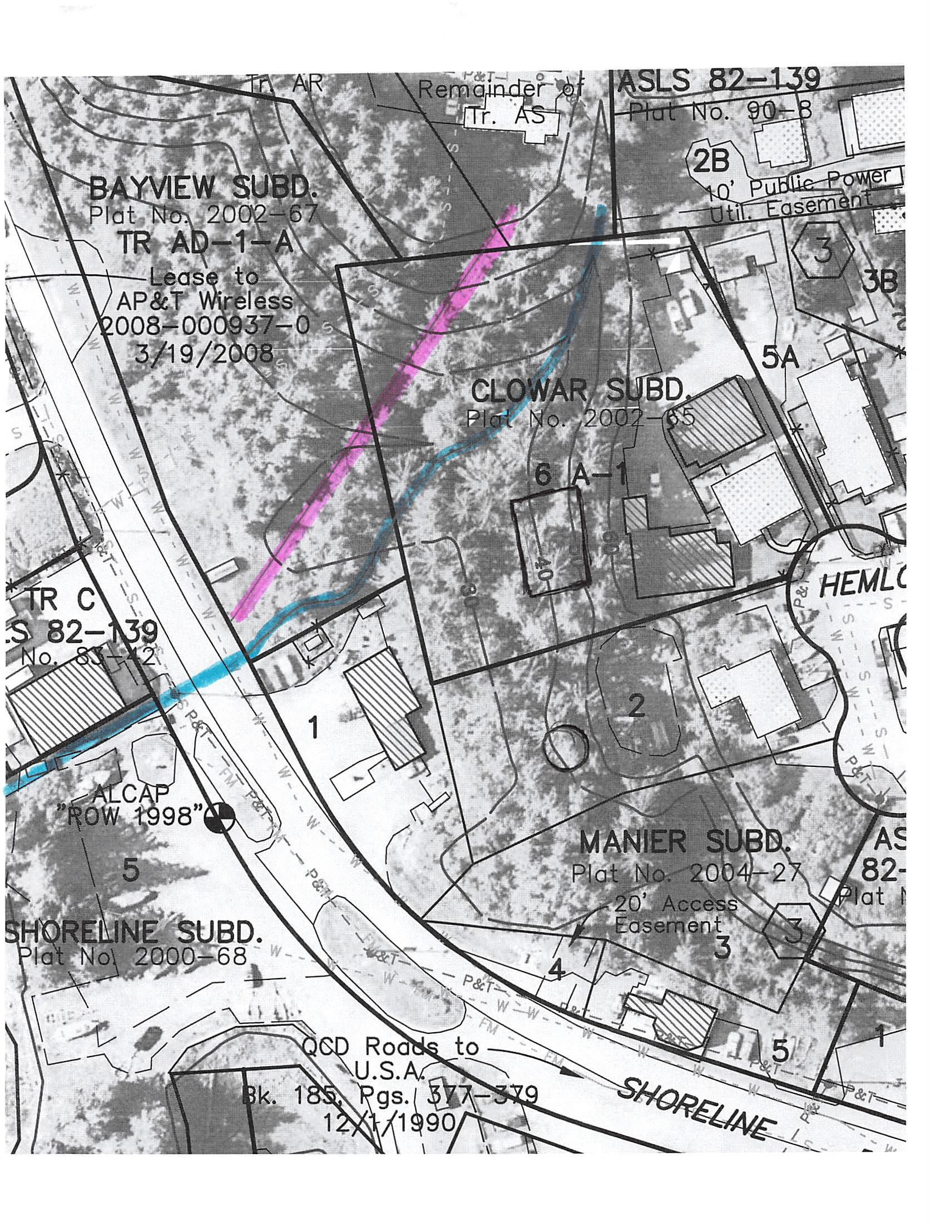

..

,.---·--,
? _{i} '_{I}
' 1
) ,
.· J

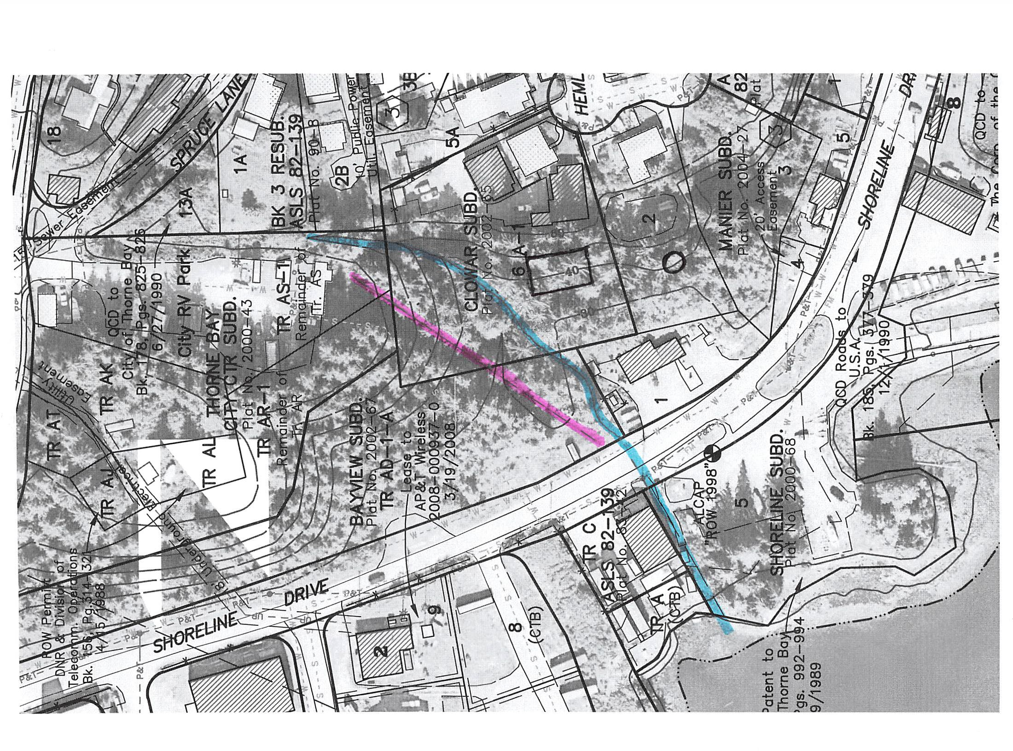

·r 1 I
\ I
l
I '
}
- .

0

-A N· 0 Y
O A D ,/'_,..,..\ COUNCIL CERTIFICATE . CERTIFICATE .Of APPROVAL BY THE
D £ A C H R .,...,••' \. I noroby -.r!,ity t!wl tt•i• plot co.nfQl'mit to TJtumn Buy 8,0ARO Pl

·
5 · ... - -- T
·-.· ·-··- ------1_ ..----· ; 1 \ · · · reg- Bci)'(;No&lto, c:nzl ttiat
,,.,.,., ; \ CouoelJ Ho1olution·No.Oote: «ru41., 20..C? · . .
--·-····•.. ·•"( . \ /;-;:;., , [ t1or !JY. cartjfy lh t; \llc;:s .lldlviskl" P.lo,t • C?•O I\Of!!Cll
i · \ ,,,,_ .....{ -ere:::!'::· _{nos} _{l>allll} .found lo.. \h the oubcli111a1on

dt'ff'.e.Cil)f l'.'Tiilil'lje·
! I \ l"c,r1"orna ea, Ci\y Counell IO'plC!.lllll')oe..n··'a·: he piottln9 Boord':{
- 1R. T AT j \ '. \ TAX STATEMENT U: la\'■h;: ..f ,,·= n .p l'O',c-l

- l: /1 tl
··.:."-.;:... \\
· . · ' · · ·
b rililo..n,lf• ": lnlJi.•

l7oftn1
tw din;. nno•t k'Oil 0111tr1 R11cof1ma
Ofttcit,:i( (.· i!!,.n,J-1ci:iXoC·.:· ·<·.·
>--•-·--
.·,. :

f ·r .i: C{t)'¢ :8oy, MOf,trio.cl.atooflJlt111!ot,"'I• · ;· .. •· · ·.,,.. y. , · .. \ t ·
i'·'..;7 \...
...... .. .. .................... ..(.·-·· .... ...... "' ::::·.·.:f·:····.... ..................................\t; <: ;c ";;'.oft.-:. ·.t.-. U..-.m.:....:.•,,..:.? . .·::"·::·. .!1.·,.t.!..·..o..Y...t..:.'................ :.:....·-....-.-: ._.:;t·t..'·t......-.:'.;L.>.'..P..r.-.\.•:•1on·:·;l.· ·- ;:·'":3 ::L...l\I .: ·- _ :;j1:·:·:·. :...
" A' \ ·1 _,. \ tool,.ot-e,...1'Plat,90:-:8.:·.. · · : . · .· ,... .,-.;1..-,·, ··. 111 I .._, ,..'"\._
\ "< \
--• :R;\C-7, .RACT.\!( ·\ ,;,·· \ The' aQfth&l.liu ; •jo-odO :. .
. ·· .' -_?-._,· '. "l '
"'
\
, : ,

'\. . ·· · : · · · · \' • • ....
"
"\._
,
{·
PMionO•of Troe\11 Al>/J!Jl:@d "5,.f>tat
\ · 43, ecc: . b)-i]hls·:s...tiley.
o_ · ., '.:· BaIy- 1_t'n-m. ij:;.
31
i TRACl/A-S-1 \ Ttl•.! molndtl'S of,th"9>Ttiict•••r• tiot . . . . . . ·, .. '. ca:. ;·11 ·s
- .,
'·.:....,. \IU1','8 . . -ii,; --
"1«1!";"'•1.Y\. ".9 ,,-s, · ... ·\' _{(lt;'cr} -iurvo1I01:1''Fii:: "'-.·ot rrocta: · - •· .,. •·,-,::.:•:-· •· · · ·Vlcl A'Y.: MAP- i•:'i :' -: :·.icale·

·, .
'- . '--. \ l R0
T.. Ai(CT . · ·.
···.·.J• Pl1to .2o®d.0.o◄J
··'\. ,
PPtt:·Jr;,:occc;tA, !l.- :U,J.od,_4o00sSi:qi ,i:tt' ··cuRV· E TA,B E·
··;_-.•·:.
. . .: C•-c;...-1..i1;;F;,I••Cs•A,-•T·'£· O.. ,F.,·.O,....\.Y...,.N........... •P"'•!.•P..·.,:•."..·..'·••·•·
. . .. .

" ' '-. \ _,.::._ f \
11/ :. 1
•

. CURVE RADIUS AAq 0£.l.TA. CHORD CD. BRG. Wo li•ro.by certify Uu.lt r,o ore .tM O.llf'l•n ot. lh• propo ty s!IOwn

" ',_ \ / "-, .i \ Pt,Tnn:tAS- j, OOSq. t. ·c-1 40.00'!4:u,·•.·. ...··.•5 •• 39. ' S18•.13'.07.''W onddOl!CribfJ·cJ··heroon·und.•lho•l,.io..: ',.oooptthas·plo.t.o. f

. , '\. \
, \ /
/ ""-.. " :. \ \
(40;00' 4r,ur ;.. '.49" Jll.'34"· s1a-w,a R.) ou lon with our free coi,.uilt.,an " !Coto .otf C! Ol'l'l!t• .

'· ' ' / " ! ._ · , . .:.:- · .....,.... 1trocl1,cd1ey:S,,-alks,.park2at1ct.otho1'0p,nspocos.19-Pl-1.,.,co.r_

I ·, \. \. ,./ fRACT AR-1 .)•·>>.,, ; .. _,./ ', (40.00' .1.IZ' ;!\ 49'' 41 '.· ;.r•:-ttt.} j
10:.q-cn­

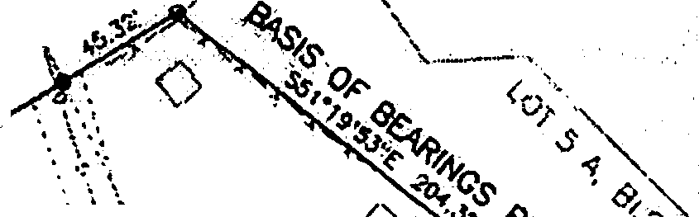
' . '\. '\,' Romairutor..t·.oflrcicl AR, -:;,.i, t- \ ·
·F', :/ . \
"' '-.. Pl t;;lClC0-:4.3 ·.
,.c•' -- c-2 40.00'_ 51.28' 7ffl'J5- 47a · 5-4a•0S'35"!E· plivci\• usa•!i(Jl91(4• · - · · · ·

Oato

' . . ,,
, \_.
1s u,.'. _{el} . ;\.' - l).'-,, : f : .
,, - .-..·· . - - 9;.alJij;J.

' ··, \., ,
'\ ' '\,
.
"
·,
c•lo!', '. •
,, : I : g
'-..., ; . tJ'>'
i

Ownor· Tr:ill/1-11 Clower, PC!. Box :1!J 61, Datil

"-.,
"'- "'•""
·-----... "
:''I- i •
. 11-.0,-0

' . ::r:i'-"! i:•.
·.• \ . .-..
  - [a
Own•r Ctly of 'Thorne Boy; PO Boii 18110, Dolo

\-.. ' ; ' ' c-, .. ·. ,·.-, Q ,.,
u
'--... '- :•.'.'.). ; r ·"1'.. \ ' / '- >/, .,
Thome Bo)·, AK 99919
S.!,.l_tilc:r.ib1ad.-a-nd-11wom lo before.me th1t.!1:. de)' ol

' '·
1'·•· . •'/;{( '·t, A- 1 / \/ t ::··\,_o} #
• '-.. ·.. . .. •·.J, I ' •:•
·/':,?\":•..;.t..4.....:·.·
\• "·,, ' ,..,,.( ,..
\;,,·./,
NOl'ARY'S ACKNOW.IJ:DGD,.i TS."" .
20 ° .. .

lojl.N. ',, "-,
{0/
•
II)

c,, /
··•····•··1
.
t.N. ··,, ·, .....
" '"-
"-.., .' /1t>f---.. . . ,-"56j?3:?,Sq. F't. ,-.I ,!. ft!/;-
,'°: ...·'>· ·· \,l.30to· ).) u - -
', :'
·rft>,\ ...,r '
0
:D,9}JA- C. wt/1..
- r
PerilonoOy OPJWIOl"ftd ·O ,J --

' '-. TRACT AO 1 . / ; . ·' ) ••• ·-. 1. •\ \. ,.,,.. . ·.,
' " - • · · ' -/ , \
' - ..,.A.-

'- ·"' Rcm lnd···"r f. ·tract -· / .:,. ;'7.,, / \ '\ f.,\ . \ · -.. ..:,. ·. .. H

'- , ,
Plot 2.0.,00-43
••· /
,: IP:."a./' ,.:: /.....o,.,..,,, ,;;._. '1(,_., <> v> • • •- · .
!::tt11tmtn1
' ', ,

f /'·-;:/: '\\·., . t : · \or
' ·· 6,,39 Acru ,' : !.· / • • '/. \'· •. \.,/'\. · '\..

. . . "" >-..,
......... /
7.· cKX .· ··:•,, jt,
-Pcrwnoliy oppaor<t4 · Kr!" - • - - -l

" "' , :,_. ·It"· ....
"-•, o / ..'' "••.
i ;. _' ! Cl; •, {p ..._,'f'. 0 / • ··· :;.• ··
,, , ·, ; ! • • r • .-- -., - / REC0ft0£D-Fi.EO
'· ' '•. : f .' : ) ; , A - •i / 0:tcbi·4n t.:.

') /'
} -"" ' ..t..-. ==--=----,.
Nototy Public; tor the Stele of lco ':(
t,ly Commlseion Ecplr11e 12 • 0

'""' -..,'-.., / ;; / ../ t/
}fi. \'b. ///
t.i!>-r.

, , '-' ,: f : / ./ ,•
t\•
,p\Vl._',,A \t•" //
v•.,.n.. _·::• ,., .·

"-- N, . . r ./'- v, .... .,.'"E •"'-
fl·•)>Ca AN
50 0
50 100

. - , .. "'-{ : . ,; / 1.-::; "-\ -r.'b:s.. ./ _.,-,...,.;;+-,rr f\¥
.. u' ... , .... ,. '- '"\-:.<{· \ - ....-·-·----
ffiTTTJ1TB ·i I
CRAAAlC SCA!.t - FEE:!'
', 0 ...'
,,
,.....
,,
, ..
\ 'lp -

Source: NOM Cnart
"'- -s·,, ',j :' j',, . - .\'-t,.\_,_-) .,;,\ - .

,,;, <, ... ',
No. 17423, ciolea 1998
' '.....(,tit'. . , -\ . s·
PO.T Cf':
7 CLOWAR SUBDMSION.

SURVEYOR'S CERTIFICATE
I h.lAI>): c:•r"Jty-that t :propa,1)1 rogioterei: O'l<I
i,, I \_!19.31·....,. ------r-'-.,...-- ....
s;._.. sss•oe•24"W ·
,.,,,, ·, , - I
\ ,. <"'·, ., .
=--
I
. ',, a . ·,-...
"
, -

A Re11:,Dlii'<i11ion of:
Lbl 6-.o.. Block • .P6"lS •1!2-i 39, Plot 90-11
Parllons of 1t0t".s ·AD; Ml and ,s Plot ·2000-43

-lleenseiHo proc.lii» Jocid S11Mxin; In: S-.i:lto of
Afo1J10, th.at lhii·Plcil llt.:1111 IUi'V tnado l)y
- !'"It .or. undeJ- IJl)'·cf11ut aupcrvblorl, thol th4t

ir: t t =t
.
'' ,-,/P. ,,'--
•, ••'- _j
---===:=----

l.ocoied ,ri\hin Se . 27, T 71 S, 64 £. CAM, Ala

ls .,.ii:1

.-o,.., c:ornic.t,
a?J' :.!r· d<11oil1
·- ,-".::> ::---
Contair,ino 1'30.Aom
' s , v•Y•O·'°' a,.(
KETC!'lit<MI REC<> .OISTRICT

G ..·Jf
CRAl PU!f, MRI.S No. J-491

•-.(.f'Jll.,no cKl111in; a11co11ilory tr,ciflUfflotit -...
J

'. . . --
ro.:.;;;,. ;,:it :p B .it:ASS;
Thorne. Ba:,, ,'K 99919 ·. KEJCtl AK, - .

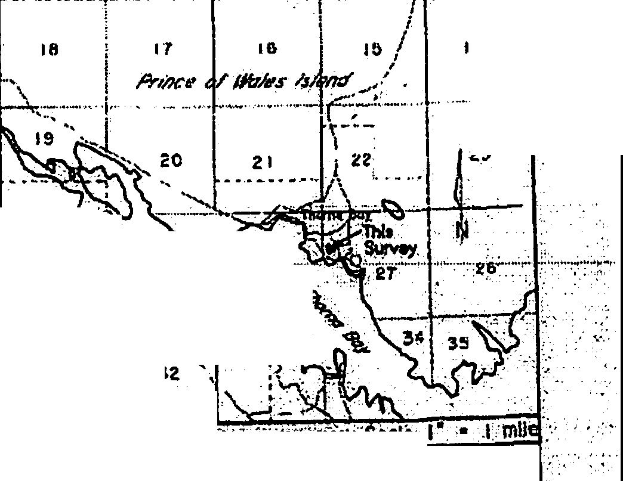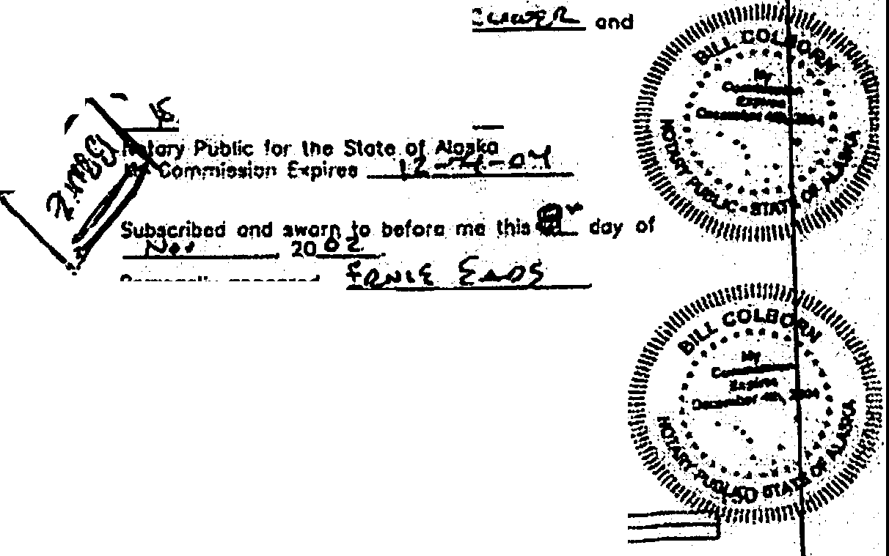k-U.-o'Z...
Doto
•'i 5/8" robur •/'Z· >J.Cl,P -·---- .- ----- ------ .
(907t - , 2_0·

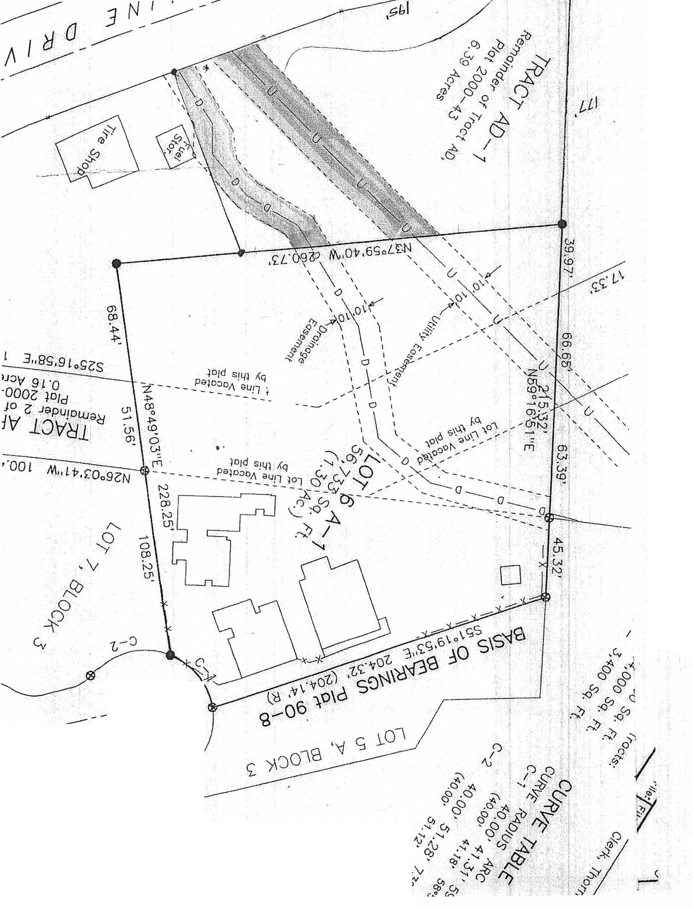

I

---------7=:t:
II

,
.----
I

1I \')

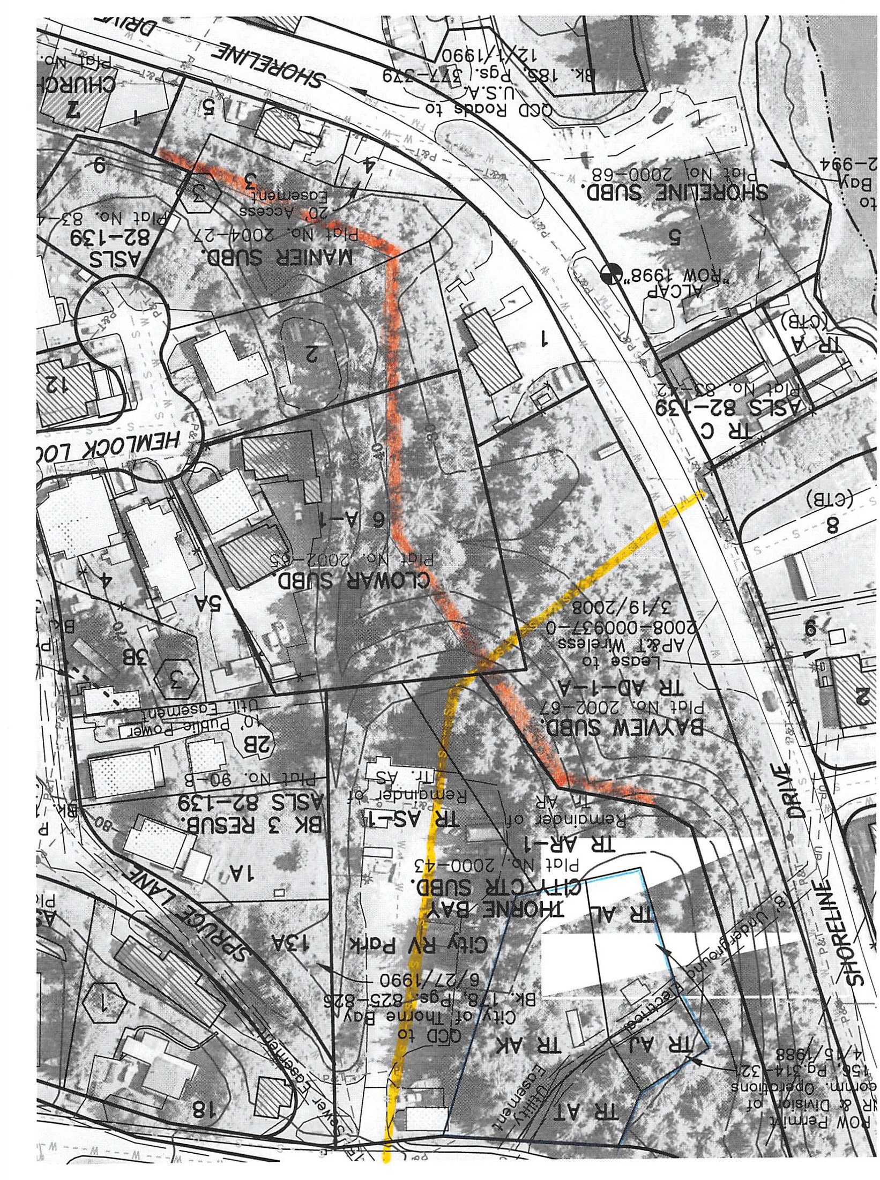

SOUTHEAST
CONFERENCE
612 W. Willoughby Ave., Suite B
P.O. Box 21989, Juneau, AK 99802
Phone (907) 586-4351
www.seconference.org Email info@seconference.org
SOUTHEAST ALASKA REGIONAL DEVELOPMENT ORGANIZATION

May 23, 2018

I.• ( l',

Wayne Brenner City Manager
City of Thorne Bay
-----·"3- --^{G}-

I y 2 2118

J

PO Box 19110
Thorne Bay, AK 99919-0110
f .. . ;' I ., f
- .. 'JI
.,·cT r: " ,1 \/

Dear Mr. Brenner;

Southeast Conference (SEC) is particularly grateful for the support from Thorne Bay that has made the progress on the AMHS Reform project to be the greatest success of the year! Two years ago, Lt. Governor, Byron Mallott told Southeast Conference members that the Alaska Marine Highway System was in crisis and an action plan was needed or the system could fail completely. As a community that interacts with the ferry system on so many levels, you know how vital AMHS is to Thorne Bay, its citizens, businesses, as well as the entire region and state of Alaska.

Today, because of the generosity of Thorne Bay and many other donors along with the hard work of our steering committee and consultants, there is a legislative solution that provides a framework that could revolutionize the ferry system.

There is a lot more work to do.

Now that HB 412 (reforming AMHS as a public corporation) has been intro duced, it will be necessary to engage stakeholders across southeast and the state to refine and revise the proposed legislation. The project group also wishes to retain our consultants to assist with guiding the transition and planning for
the next generation of vessels, terminals and service. These costs, along with project management, travel and public outreach add up quickly.

Southeast Conference respectfully asks that you consider whether there is an opportunity to again support this project financially during this fiscal year or next. A contribution of any amount will be appreciated and will continue to be recognized in all our presentations and on the project website (www.AMHSreform.com).
On behalf of the Southeast Conference Board of Directors and the AMHS Reform Steering Committee, Thank you.
!JraN
Robert Venables Executive Director Southeast Conference

SOUTHEAST
CONFERENCE
Alaska Marine Highway System Reform Sponsorship Program
This projec t has been very successful, thanks to the many organization s and individuals who have cont ributed to the Alaska Marine Highw ay System Refor m Project. For nearly 2 years, Alaskans have provided valua ble input and the statewide steering committee and consultants have worked hard to provide a path forward to make AMHS a more viable and reliable part of the public' s tra nspo rtat ion system.
We cannot stop now. The Legislat ure has formally intro duced HB 412 which will need presented to the public, refined then reintroduced for the next legis lati ve sess ion. Southeast Conference is counting on the many stakeholde rs who see the critical role the ferry sys tem has in supp orting our communities and busin esses to help s up por t this e ffo rt financially. Sponsors hips not only move this project forward they are recognized in each of our presentations and on the project website. If you would like to participate, call SEC at (907) 586-4351 or complete the form below and mail, fax, or email to robert@seconference.org

Legacy | $10,000
Benefactor | $5,000
Gold | $3,500
Silver | $2,500
Bronze | $1,500

No amount is too big or too small, any amount is welcome!
Other amount $
Name: -- - - - - - - - - - - - - - - - - - - - - - - - - - - - - - -

Co mm uni ty/ Org a nizatio n:_.
_ _ _
_ _ _ _
_ _ _ _ _
_ _ _ _
_ _ _ _
_ _ _ _
_ _ _ _ _ _

Address: ._ _
_ _ _ _
_ _ _ _
_ _ _
_ City:_ _
_ _ _ _
_ _ _
_ State & Zip:_ _ _
_ _ _ _

Phone: _
_ _ _ _
_ _ _ _ _ _ _ _
_ _ Fax:_ _
_ _ _ _
_ _ _ _ _ _
_ _ _ _ _

Email:_ _ _ _
_ _ _ _
_ _ _ _ _
_ _ _ _
_ _ _ _
_ _
_ _ _ _
_ _ _ _ _ _

Payment O ptions: □
Charge to Credit Ca rd:
C heck en close d D

Card Num be r: _ _ _ _
_ _ _ _
_ _ _ _
_ _ _ _
_ _ _
_ _ _
Exp. Da e_t: _
_ _ _

Name as it appear on the card:_ _
_ _ _ _ _ _
_ _ _ _ _
_ _ _ _
_ _
_ _ _ _ _ _

  - Digit Iden tifie rs:_ _ _ _
_ _ _ Statemen t Zip Cod e:_ _
_ _ _ _
_ _ _ _

Signat ure:_ _ _
_ _ _ _ _ _
_ _ _ _
_ _ _ _
_ _
_ _ _ _
_ _ _ _ _
_ _ _ _

This Rental Agreement is entered into by and between the City of Thorne Bay, Alaska, P.O. Box 110, Thorne Bay, Alaska 99919 (hereinafter called the "CITY "and, Southeast Road Builders. (hereinafter called the "RENTER").

    - Rented Premises. The City does herby Rent to the Renter Lots 6 and 7 of the Business District Subdivision on municipally owned property within the corporate boundaries of the City of Thorne Bay.

Municipal Code, Title 2, Article Ill, Incorporated. The provisions of "Title 2, Article Ill of the Thorne Bay Municipal Code shall apply to the terms of this Rental Agreement unless otherwise amended in this Rental Agreement.

    - Term. The term of this Rental Agreement shall be Two (2) year(s) beginning June 1s•t
2018 and

ending May 31, 2020. Monthly rental payments due the City shall commence prior to use of Rented Premises and continue throughout the term of this Rental Agreement. Monthly Sales Taxes due the City shall commence upon the signing of Rental Agreement. Renter shall have the option to renew this Rent for an additional period of time subject to renegotiations of Rent terms and payments acceptable to both the City and Renter. The option to renew and Rent for the additional period can only be effective upon approval by the Thorne Bay City Council. This option to renew shall be exercised by the Renter in writing sixty {60) days prior to the expiration of the original Rent term.
The option to renew is specifically waived if not exercised in full compliance with this provision.

This Rental Agreement expires automatically on the last day of the Two (2) year period absent the approval of a new Rental Agreement by the Thorne Bay City Council. Absent an approved Rental Agreement, the Renter shall vacate the premise on or before the ending date of this Rental Agreement.

In addition to any rights of the City to terminate this Rental Agreement as specified in this Rental Agreement, or as specified in the Thorne Bay Municipal Code, the City shall have all rights to terminate this Rental Agreement in accordance with any provision of applicable law.

    - Monthly Rent Payment. Renter covenants and agrees to pay City monthly Rent payments in the sum of One Hundred Fifty Dollars ($150) plus applicable sales tax payable in advance on the first day of each month of the Rent term. In the event any payment required to be made pursuant to this Rental Agreement is more than ten {10) days past due, a late charge equal to ten percent (10%) per annum on such past due amount will be assessed and charged to Renter by City. At the expiration of two-year term the monthly Rent payment shall be reviewed and adjusted in accordance with the provisions of Section 2.56.210 of Title 2, Article Ill of the Thorne Bay Municipal Code.

    - Deposits. Renter shall deposit with the City an amount equal to N/A. Upon termination of the Rental Agreement the Renter shall vacate the premise leaving it in the same clean condition as presented at the time said Rental Agreement was initiated. If the premise is in need of cleaning, repairs or the Renter is in default in payments said deposit shall be used to offset such costs. In the event the Rented Premise is clean and in need of no repairs the deposit will be refunded in full.

Page 1 of 7

First and last month may be waved in lieu of improvements to the Rented Premises or other City Facilities as provided by Renter per "Exhibit A11
•

    - Use. Renter shall use the Rented Premises for the purposed of maintaining and operating there on; Storage of Southeast Road Builders Equipment and Supplies. The Rented Premises shall be used for no other purposes without the prior written consent of City.

    - Utilities and Fees. Renter shall be responsible for all utility accounts and applicable deposits for said accounts. Renter agrees to pay, and keep current, ALL charges, including deposits, for all utilities, including but not limited to water, sewer, refuse collection, electricity, propane, fuel oil and telephone. Failure to do so will result in the utility being shutoff. Activation of a city shutoff shall constitute a material breach of the Rent Agreement resulting in the City's termination of the Rent Agreement. Absent an approved Rental Agreement, the Renter shall vacate the premise immediately.

    - Repairs, Maintenance and Compliance with Laws. Renter shall maintain the Rented Premises at Renter's sole cost and expense and at all times keep the Rented Premises neat, clean and in a sanitary condition. Renter shall keep and use the Rented Premises in accordance with applicable laws, ordinances, rules, regulations and requirements of all governmental authorities. Renter shall permit no waste, damage or injury to the Rented Premises. Renter's use of the Rented Premises in violation of any law or regulation of any governmental entity related to public health or safety or environmental pollution shall be a material breach of the Rental Agreement and grounds for City's termination of the Rental Agreement. Renter is required to obtain building permit authorization from the City for construction of any and all structures placed on or in the Rented Premises.
    - Signs, Alterations and Improvements. All signs or symbols placed on or about the Rented Premises shall be subject to City's prior written approval. After prior written consent of City, Renter may make alterations and improvements to the Rented Premises, at Renter's sole cost and expense. City may elect to require Renter to remove any such alterations and improvements upon termination of this Rental Agreement at Renter's sole cost and expense. Any of Renter's improvements remaining on the Rented Premises longer than thirty {30) days after Renter's possessors rights to the Rented Premises have expired shall become Rented Premises of City.

    - Insolvency. In the event Renter becomes insolvent, bankrupt or if a receiver, assignee or other liquidating officer is appointed for the business of Renter, City, in City's sole discretion may immediately terminate this Rental Agreement and require that Renter vacate the Rental Premises.

    - Subletting or Assignment. Renter shall not sublet the whole or any part of the Rented Premises nor assign this Rental Agreement without the prior written consent of City. This Rental Agreement shall not be assignable by operation of law. All terms and conditions of the Rental Agreement shall be binding upon any sub Renter or assignee of this Rental Agreement and Renter shall remain fully responsible to City for performance of this Rental Agreement.

    - Permits and Compliance with Law. Renter shall obtain all necessary local, state and federal permits necessary for the operation of Renter's business and shall comply with all local, state and federal laws, rules and regulations.

Page 2 of7

Failure to comply with any requirements of this section shall constitute a material breach of the Rental Agreement. Failure to remedy the violation within 30 days will result in the City's termination of the Rental Agreement. Absent an approved Rental Agreement, the Renter shall vacate the premise immediately.
    - Insurance. General Liability Insurance: The Renter shall procure and maintain during the life of this agreement, General Liability Insurance on an "occurrence basis" with limits of liability not less than
$1,000,000 per occurrence and /or aggregate combined single limit, personal injury, bodily injury and property damage.

Proof of Insurance shall be provided to City within thirty (30) days after the parties have executed this agreement and prior to public use of said premises. City shall be notified at least thirty (30) days before the cancellation or termination of any policy.

City shall be named as additional insured.

    - Accidents and Liability. City or its agent shall not be liable for any injury or damage to the persons or property sustained by Renter or others, in and about the Rented Premises.

    - Indemnification and Waiver of Subrogation. To the fullest extent permitted by law, the Renter agrees to defend, indemnify and hold harmless the City, its elected and appointed officials, employees and volunteers against any and all liabilities, claims, demands, lawsuits, or losses, including costs and attorney fees incurred in defense thereof, arising out of or in any way connected or associated with this agreement.
To the extent permitted by law, the Renter hereby re-Rents the City, its elected and appointed officials, employees and volunteers from any and all liability or responsibility to the Renter or anyone claiming through or under the Renter by way of subrogation or otherwise, for any loss or damage to the property caused by fire or any other casualty, even if such fire or other casualty shall have been caused by the fault or negligence of the City, its elected or appointed officials, employees or volunteers. This provision shall be applicable and in full force and effect only with respect to loss or damage occurring during the time of the Renter's occupancy or use.
Renter understands that the City accepts no responsibility whatsoever for loss of, or damage to Renter's property.
    - Removal of Renter's Property and Repair of Rented Property. All buildings, fixtures and equipment of whatsoever nature, that Renter shall have acquired and installed upon Rented premises, whether permanently affixed or otherwise, shall continue to be the property of the Renter and must be removed by the Renter at the expiration or termination of this Rental Agreement; and at its own expense, Renter shall repair any injury to Rented Premises resulting from such removal. Renter shall remove all buildings, fixtures, and equipment, and make all repairs, within thirty days of the date the Renter vacates Rented Premises. If the Renter fails to remove its buildings, fixtures, and equipment, and fails to make the necessary repairs, the City may do so, and seek reimbursement from the Renter for the full amount of the repairs, without any deduction for the value of any buildings, fixtures, or equipment left on the premises by the Renter. If City determines that it is in City's best interest to

Page 3 of7

acquire the improvements, it may negotiate to purchase Renter's buildings, fixtures, and equipment at a price equal to or less than fair market value.

    - Taxes. Renter shall be solely and fully responsible for the payment of all applicable federal, state, and Thorne Bay municipal taxes including all Monthly Sales Taxes due the City.

    - Liens. Renter shall maintain Rented Premises free of any and all liens. Renter will not permit any mechanics', laborers' or materialmen's liens to stand against the Rented Property or improvements for any labor or materials furnished to Renter or claimed to have been furnished to Renter, or to Renter's agents, contractors, or sub-Renters, in connection with work of any character performed or claimed to have been performed on Rented premises or improvements by or at the direction or sufferance of Renter; provided, however, Renter shall have the right to contest the validity or amount of any such lien or claimed lien, In the event of such contest, Renter shall give to the City such reasonable security as may be demanded by the City to insure payment of such lien or such claim of lien. Renter will immediately pay any judgment rendered with all proper costs and charges and shall have such lien re-Rented or judgment satisfied at Renter's own expense. Renter agrees to indemnify, hold harmless and to defend the City and Rented premises from such liens. Renter consents to the City's recording of and posting of a statutory notice of non-responsibility in accordance with Alaska Stature 34.35.065

    - Default by Renter. Each of the following shall be deemed a default by the Renter and a breach of the Rental Agreement:
      - A failure to make payment of any installment, of rent or of any other sum herein specified to be paid by Renter, and Renter fails to cure such default within ten (10) days after receipt of a written notice has been received by Renter specifying such failure to make payment;
      - Upon shut off of utilities;
      - A default in the performance of any other covenant or condition on the part of the Renter to be performed for a period of thirty (30) days after receipt by Renter of a notice specifying the particular default or defaults;
      - The filing of a petition by or against Renter for adjudication as a bankrupt, or for reorganization or arrangement within the meaning of the Bankruptcy Act;
      - The dissolution or the commencement of any action or proceeding for the dissolution or liquidation of the Renter or for the appointment of a receiver or trustee of Rented Premises of the Renter;
      - The taking possession of Rented Premises of the Renter by any governmental officer of agency pursuant to statutory authority for the dissolution of liquidation of the Renter;
      - The making by the Renter of an assignment for the benefit of creditors;
      - Renter vacates or abandons the Rented Premises; and
      - A failure that continues for five (S) days or more to have the City named as an additional insured as required under paragraph 18, and Renter fails to cure such default within ten (10) days after receipt of a written notice has been received by Renter specifying such failure to name the City as an additional insured.

Page 4 of 7

The specification of events constituting default by the Renter in this Section, are in additional to any defaults specified in the Thorne Bay Municipal Code.
    - City's Remedies for Default. In the event of any default of the Renter, the City shall have the following rights and remedies - all in addition to any rights or remedies that may be given to the City by statue, common law, or under Thorne Bay Municipal Code.
      - Distraint for rent due and subsequent sale of chattels so distrained. The sale of any such chattels shall be in accordance with the procedure set forth in Alaska Statues.
      - Re-enter Rented Premises and take possession thereof, remove all persons therefrom, and remove Renter's property therefrom and store it in a public warehouse or elsewhere at the cost of Renter, all without service of notice or resort to legal process (all of which Renter expressly waives) and without becoming liable for trespass, forcible entry, detainer, or other tort or for any loss or damage which may be occasioned thereby;
      - Declare the Term ended;
      - Re-let Rented premises in whole or in part for any period equal to or greater, or less, than the remainder of the Term for any sum which is commercially reasonable;
      - Cure any such default, if possible, and demand immediate payment until all costs incurred in curing the default have been reimbursed fully, together with interest calculated at the rate of ten percent (10%) per annum at the then current prime rate as established by the First Bank of Alaska;
      - Collect all reasonable damages, costs and expenses that the City may incur by reason of default by Renter, together with interest calculated at the rate of ten percent {10%) per annum at the then current prime rate as established by the First Bank of Alaska.
      - The City shall use reasonable diligence to relet Rented Premises in or to mitigate the City's damages, consistent with the uses of Rented Premises, and all applicable Thorne Bay code provisions related to this Rent and Rented Premises.

    - Rights and Remedies. Except insofar as this is inconsistent with or contrary to any provision of this Rent, no right or remedy herein conferred upon reserved to the City or Renter is intended to be exclusive of any other right or remedy, and each and every right and remedy shall be cumulative and in addition to any other right or remedy given hereunder, or now or hereafter existing al law or in equity or by statute.

    - Waiver. Except to the extent that a party may have otherwise agreed in writing, no waiver by a party of any breach by the other party of any of its obligations, agreements or covenants hereunder shall be deemed to be a waiver of any subsequent breach of the same or any other covenant, agreement or obligation. Nor shall any forbearance by a party to seek a remedy for any breach of the other party be deemed a waiver of its rights or remedies with respect to such breach.

    - Changes. No modifications, amendments, deletions, additions or alterations of the Rent Agreement shall be effective unless in writing and signed by all of the parties hereto and such representatives of the parties as have been duly authorized to make such changes.

    - Joint Product. The language set out in this Rental Agreement represents the joint product of the parties and shall not be construed against one party in favor of the other. Each party hereto has

Page 5 of 7

had the option of seeking the advice of legal counsel in the drafting of this Rental Agreement, and the rule of construction favoring construction against the draftor shall not apply. Renter acknowledges and agrees that Renter has not received any legal advice from the City's attorney or from anyone associated with the City.

    - Authority. The parties and their undersigned representatives warrant that they have full authority to enter into this Rental Agreement and to execute this Rental Agreement.

    - Hazardous Materials. The Renter shall not permit, store, manufacture or dispose on Rented Premises any hazardous material or controlled substance as determined by federal, state, or municipal statures or laws now or at any time hereafter in effect, including but not limited to, the Comprehensive Environmental Response, Compensation and liability Act (42 U.S.C. 9601 et seq.), the Hazardous materials Transportation Act {42 U.S.C. 1801 et seq.), the Resource Conservation and Recovery Act {42 U.S.C. 6901 et seq.), the Federal Water Pollution Control Act {33 U.S.C. 1251et seq.), the Clean Air Act {42 U.S.C.7401 et seq.), the Toxic Substance Control Act, as amended {15
U.S.C. 2601 et seq.), and the Occupational Safety and Health Act {29 U.S.C. 651et seq.), and Title 46 of the Alaska Statutes as these laws have been and may hereafter be amended or supplemented. "Hazardous Substance" means any pollutant, contaminant, toxic substance, flammable, explosive, radioactive material, urea formaldehyde foam insulation, asbestos, PCB's or any other substance the removal of which is required, or the manufacture, preparation production, generation, use
maintenance, treatment, storage, transfer, handling or ownership of which is restricted, prohibited, regulated or penalized by any and all federal, state, or municipal statutes or laws now or at any time hereafter in effect. Hazardous material shall not include cleaning supplies used in the routine daily cleaning and operation of a restaurant.

    - Acceptance of the Rented Property by Renter. Renter acknowledges that it has thoroughly examined Rented Premises. Renter accepts Rented Premises in their "AS IS" condition, and the City shall not be required to perform any work to prepare Rented Premises for the Renter. Renter's taking possession of Rented Premises shall be conclusive evidence against it that, at the time possession was taken, Rented Premises were in good and satisfactory condition. Renter acknowledges that, except for those representations and statements regarding the condition of Rented Premises expressly stated herein, Renter has not relied upon any representations or statements of the City or its representatives or agents regarding the condition of Rented premises or their suitability for Renter's uses under this Rent.

- Attorneys' Fees and Costs. Should any dispute and/or legal action arise by reason of any default or breach on the part of Renter in the performance of any of the provisions of the Rental Agreement, Renter agrees to pay all reasonable attorneys' fees and costs incurred by City in connection therewith including City's attorneys' fees and costs incurred on appeal. It is agreed that the venue of any legal action brought under the terms of this Rental Agreement will be the First Judicial District, at Ketchikan, Alaska. Renter specifically agrees that venue for trial in any action related to this Rent shall be in Craig, Alaska.
- No Waiver of Covenants. Any waiver by either party of any breach hereof by the other shall not be considered a waiver of any future or similar breach. This Rental Agreement contains all the

Page 6 of7

agreements between the parties, and there shall be no modification of the agreements contained herein except by written instrument signed by both parties.

- Surrender of Rented Premises. Upon termination of this Rental Agreement, Renter agrees to peacefully quit and surrender the Rented premises without notice, remove all of Renter's personal property and leave the Rented premises neat and clean. If City elects to require Renter to remove any alterations or improvements made by Renter, then Renter shall restore the Rented Premises to their previous condition, at Renter's sole expense.

- Binding on Heirs, Successors and Assigns. The covenants and agreements of this Rental Agreement shall be binding upon the heirs, executors, administrators, successors and assigns of both parties thereto, except as hereinabove provided, and as allowable by law.

- Notice. Any notice required to be given by either party to the other shall be deposited in the United States mail, postage prepaid, addressed to City at P.O. Box 19110, Thorne Bay, Alaska

99919, or the Renter at address as either party may designate in writing to the other.
oart such other

- City's Right of Entry. The City shall have the right to enter Rented premises at all reasonable times to examine the condition of same.

IN WITNESS WHEREOF, the parties hereto have executed this Rental Agreement as of the date first set above written.

CITY: RENTER:

THE CITY OF THORNE BAY

By Harvey McDonald, Mayor "City"
By Southeast Road Builders "Renter"

ATTEST:

Teri Feibel, CMC, City Clerk/Treasurer

Page 7 of 7

This Rental Agreement is entered into by and between the City of Thorne Bay, Alaska, P.O. Box 110, Thorne Bay, Alaska 99919 (hereinafter called the "CITY "and, Ken Batten. (hereinafter called the "RENTER").

- Rented Premises. The City does herby Rent to the Renter one (1) acre plus or minus of land at the Sort Yard along the road to the Heli Port. See Attached Exhibit on municipally owned property within the corporate boundaries of the City of Thorne Bay.

Municipal Code, Title 2, Article Ill, Incorporated. The provisions of ''Title 2, Article Ill of the Thorne Bay Municipal Code shall apply to the terms of this Rental Agreement unless otherwise amended in this Rental Agreement.

- Term. The term of this Rental Agreement shall be Two (2) year(s) beginning June 1. 2018 and ending May 31. 2020 . Monthly rental payments due the City shall commence prior to use of Rented Premises and continue throughout the term of this Rental Agreement. Monthly Sales Taxes due the City shall commence upon the signing of Rental Agreement. Renter shall have the option to renew this Rent for an additional period of time subject to renegotiations of Rent terms and payments acceptable to both the City and Renter. The option to renew and Rent for the additional period can only be effective upon approval by the Thorne Bay City Council. This option to renew shall be exercised by the Renter in writing sixty (60) days prior to the expiration of the original Rent term. The option to renew is specifically waived if not exercised in full compliance with this provision.

This Rental Agreement expires automatically on the last day of the Two (2) year period absent the approval of a new Rental Agreement by the Thorne Bay City Council. Absent an approved Rental Agreement the Renter shall vacate the premise on or before the ending date of this Rental Agreement.

In addition to any rights of the City to terminate this Rental Agreement as specified in this Rental Agreement, or as specified in the Thorne Bay Municipal Code, the City shall have all rights to terminate this Rental Agreement in accordance with any provision of applicable law.

- Monthly Rent Payment. Renter covenants and agrees to pay City monthly Rent payments in the sum of One Hundred Fifty Dollars ($150) plus applicable sales tax payable in advance on the first day of each month of the Rent term. In the event any payment required to be made pursuant to this Rental Agreement is more than ten (10) days past due, a late charge equal to ten percent (10%) per annum on such past due amount will be assessed and charged to Renter by City. At the expiration of two-year term, the monthly Rent payment shall be reviewed and adjusted in accordance with the provisions of Section 2.56.210 of Title 2, Article Ill of the Thorne Bay Municipal Code.

Page 1 of 8

- Deposits. Renter shall deposit with the City an amount equal to N....,/A _

Upon termination of the Rental Agreement the Renter shall vacate the premise leaving it in the same clean condition as presented at the time said Rental Agreement was initiated. If the premise is in need of cleaning, repairs or the Renter is in default in payments said deposit shall be used to offset such costs. In the event the Rented Premise is clean and in need of no repairs the deposit will be refunded in full. First and last month may be waved in lieu of improvements to the Rented Premises or other City Facilities as provided by Renter per "Exhibit A".
- Use. Renter shall use the Rented Premises for the purposed of maintaining and operating there on, Storage and repair of helicopters and related equipment. that includes a hanger and fuel storage for aviation use. The Rented Premises shall be used for no other purposes without the prior written consent of City. The Heli-port, the area adjacent to the Heli-port and the access road to the Heli port must remain open and available for emergency use at all times and at no time shall anything be left unattended in these areas.
- Utilities and Fees. Renter shall be responsible for all utility accounts and applicable deposits for said accounts. Renter agrees to pay, and keep current, ALL charges, including deposits, for all utilities, including but not limited to water, sewer, refuse collection, electricity, propane, fuel oil and telephone. Failure to do so will result in the utility being shutoff. Activation of a city shutoff shall constitute a material breach of the Rent Agreement resulting in the City's termination of the Rent Agreement. Absent an approved Rental Agreement the Renter shall vacate the premise immediately.
- Repairs, Maintenance and Compliance with Laws. Renter shall maintain the Rented Premises at Renter's sole cost and expense and at all times keep the Rented Premises neat, clean and in a sanitary condition. Renter shall keep and use the Rented Premises in accordance with applicable laws, ordinances, rules, regulations and requirements of all governmental authorities. Renter shall permit no waste, damage or injury to the Rented Premises. Renter's use of the Rented Premises in violation of any law or regulation of any governmental entity related to public health or safety or environmental pollution shall be a material breach of the Rental Agreement and grounds for City's termination of the Rental Agreement. Renter is required to obtain building permit authorization from the City for construction of any and all structures placed on or in the Rented Premises.
- Signs, Alterations and Improvements. All signs or symbols placed on or about the Rented Premises shall be subject to City's prior written approval. After prior written consent of City, Renter may make alterations and improvements to the Rented Premises, at Renter's sole cost and expense. City may elect to require Renter to remove any such alterations and improvements upon termination of this Rental Agreement at Renter's sole cost and expense. Any of Renter's improvements remaining on the Rented

Page 2 of 8

Premises longer than thirty {30) days after Renter's possessors rights to the Rented Premises have expired shall become Rented Premises of City.

- Insolvency. In the event Renter becomes insolvent, bankrupt or if a receiver, assignee or other liquidating officer is appointed for the business of Renter, City, in City's sole discretion may immediately terminate this Rental Agreement and require that Renter vacate the Rental Premises.

- Subletting or Assignment. Renter shall not sublet the whole or any part of the Rented Premises nor assign this Rental Agreement without the prior written consent of City. This Rental Agreement shall not be assignable by operation of law. All terms and conditions of the Rental Agreement shall be binding upon any sub Renter or assignee of this Rental Agreement and Renter shall remain fully responsible to City for performance of this Rental Agreement.

- Permits and Compliance with Law. Renter shall obtain all necessa y local, state and federal permits necessary for the operation of Renter's business and shall comply with all local, state and federal laws, rules and regulations.

Failure to comply with any requirements of this section shall constitute a material breach of the Rental Agreement. Failure to remedy the violation within 30 days will result in the City's termination of the Rental Agreement. Absent an approved Rental Agreement the Renter shall vacate the premise immediately.

- Insurance. General Liability Insurance: The Renter shall procure and maintain during the life of this agreement, General Liability Insurance on an "occurrence basis" with limits of liability not less than $1,000,000 per occurrence and /or aggregate combined single limit, personal injury, bodily injury and property damage.

Proof of Insurance shall be provided to City within thirty {30) days after the parties have executed this agreement and prior to public use of said premises. City shall be notified at least thirty {30) days before the cancellation or termination of any policy.
City shall be named as additional insured.

- Accidents and Liability. City or its agent shall not be liable for any injury or damage to the persons or property sustained by Renter or others, in and about the Rented Premises.

- Indemnification and Waiver of Subrogation. To the fullest extent permitted by law, the Renter agrees to defend, indemnify and hold harmless the City, its elected and appointed officials, employees and volunteers against any and all liabilities, claims,

Page 3 of 8

demands, lawsuits, or losses, including costs and attorney fees incurred in defense thereof, arising out of or in any way connected or associated with this agreement.
To the extent permitted by law, the Renter hereby re-Rents the City, its elected and appointed officials, employees and volunteers from any and all liability or responsibility to the Renter or anyone claiming through or under the Renter by way of subrogation or otherwise, for any loss or damage to the property caused by fire or any other casualty, even if such fire or other casualty shall have been caused by the fault or negligence of the City, its elected or appointed officials, employees or volunteers. This provision shall be applicable and in full force and effect only with respect to loss or damage occurring during the time of the Renter's occupancy or use.

Renter understands that the City accepts no responsibility whatsoever for loss of, or damage to Renter's property.

- Removal of Renter's Property and Repair of Rented Property. All buildings, fixtures and equipment of whatsoever nature, that Renter shall have acquired and installed upon Rented premises, whether permanently affixed or otherwise, shall continue to be the property of the Renter and must be removed by the Renter at the expiration or termination of this Rental Agreement; and at its own expense, Renter shall repair any injury to Rented Premises resulting from such removal. Renter shall remove all buildings, fixtures, and equipment, and make all repairs, within thirty days of the date the Renter vacates Rented Premises. If the Renter fails to remove its buildings, fixtures, and equipment, and fails to make the necessary repairs, the City may do so, and seek reimbursement from the Renter for the full amount of the repairs, without any deduction for the value of any buildings, fixtures, or equipment left on the premises by the Renter. If City determines that it is in City's best interest to acquire the improvements, it may negotiate to purchase Renter's buildings, fixtures, and equipment at a price equal to or less than fair market value.

- Taxes. Renter shall be solely and fully responsible for the payment of all applicable federal, state, and Thorne Bay municipal taxes including all Monthly Sales Taxes due the City.

- Liens. Renter shall maintain Rented Premises free of any and all liens. Renter will not permit any mechanics', laborers' or materialmen's liens to stand against the Rented Property or improvements for any labor or materials furnished to Renter or claimed to have been furnished to Renter, or to Renter's agents, contractors, or sub-Renters, in connection with work of any character performed or claimed to have been performed on Rented premises or improvements by or at the direction or sufferance of Renter; provided, however, Renter shall have the right to contest the validity or amount of any such lien or claimed lien, In the event of such contest, Renter shall give to the City such reasonable security as may be demanded by the City to insure payment of such lien or such claim of lien. Renter will immediately pay any judgment rendered with all proper

Page 4 of 8

costs and charges and shall have such lien re-Rented or judgment satisfied at Renter's own expense. Renter agrees to indemnify, hold harmless and to defend the City and Rented premises from such liens. Renter consents to the City's recording of and posting of a statutory notice of non-responsibility in accordance with Alaska Stature 34.35.065

- Default by Renter. Each of the following shall be deemed a default by the Renter and a breach of the Rental Agreement:
  - A failure to make payment of any installment, of rent or of any other sum herein specified to be paid by Renter, and Renter fails to cure such default within ten (10) days after receipt of a written notice has been received by Renter specifying such failure to make payment;
  - Upon shut off of utilities;
  - A default in the performance of any other covenant or condition on the part of the Renter to be performed for a period of thirty (30) days after receipt by Renter of a notice specifying the particular default or defaults;
  - The filing of a petition by or against Renter for adjudication as a bankrupt, or for reorganization or arrangement within the meaning of the Bankruptcy Act;
  - The dissolution or the commencement of any action or proceeding for the dissolution or liquidation of the Renter or for the appointment of a receiver or trustee of Rented Premises of the Renter;
  - The taking possession of Rented Premises of the Renter by any governmental officer of agency pursuant to statutory authority for the dissolution of liquidation of the Renter;
  - The making by the Renter of an assignment for the benefit of creditors;
  - Renter vacates or abandons the Rented Premises; and
  - A failure that continues for five (5) days or more to have the City named as an additional insured as required under paragraph 18, and Renter fails to cure such default within ten (10) days after receipt of a written notice has been received by Renter specifying such failure to name the City as an additional insured.
The specification of events constituting default by the Renter in this Section, are in additional to any defaults specified in the Thorne Bay Municipal Code.
- City's Remedies for Default. In the event of any default of the Renter, the City shall have the following rights and remedies - all in addition to any rights or remedies that may be given to the City by statue, common law, or under Thorne Bay Municipal Code.
  - Distraint for rent due and subsequent sale of chattels so distrained. The sale of any such chattels shall be in accordance with the procedure set forth in Alaska Statues.
  - Re-enter Rented Premises and take possession thereof, remove all persons therefrom, and remove Renter's property therefrom and store it in a public warehouse or elsewhere at the cost of Renter, all without service of notice or resort
P_age 5 of 8

to legal process (all of which Renter expressly waives) and without becoming liable for trespass, forcible entry, detainer, or other tort or for any loss or damage which may be occasioned thereby;
  - Declare the Term ended;
  - Re-let Rented premises in whole or in part for any period equal to or greater, or less, than the remainder of the Term for any sum which is commercially reasonable;
  - Cure any such default, if possible, and demand immediate payment until all costs incurred in curing the default have been reimbursed fully, together with interest calculated at the rate of ten percent {10%) per annum at the then current prime rate as established by the First Bank of Alaska;
  - Collect all reasonable damages, costs and expenses that the City may incur by reason of default by Renter, together with interest calculated at the rate of ten percent (10%) per annum at the then current prime rate as established by the First Bank of Alaska.
  - The City shall use reasonable diligence to relet Rented Premises in or to mitigate the City's damages, consistent with the uses of Rented Premises, and all applicable Thorne Bay code provisions related to this Rent and Rented Prem.ises.

- Rights and Remedies. Except insofar as this is inconsistent with or contrary to any provision of this Rent, no right or remedy herein conferred upon reserved to the City or Renter is intended to be exclusive of any other right or remedy, and each and every right and remedy shall be cumulative and in addition to any other right or remedy given hereunder, or now or hereafter existing al law or in equity or by statute.

- Waiver. Except to the extent that a party may have otherwise agreed in writing, no waiver by a party of any breach by the other party of any of its obligations, agreements or covenants hereunder shall be deemed to be a waiver of any subsequent breach of the same or any other covenant, agreement or obligation. Nor shall any forbearance by a party to seek a remedy for any breach of the other party be deemed a waiver of its rights or remedies with respect to such breach.

- Changes. No modifications, amendments, deletions, additions or alterations of the Rent Agreement shall be effective unless in writing and signed by all of the parties hereto and such representatives of the parties as have been duly authorized to make such changes.

- Joint Product. The language set out in this Rental Agreement represents the joint product of the parties and shall not be construed against one party in favor of the other. Each party hereto has had the option of seeking the advice of legal counsel in the drafting of this Rental Agreement, and the rule of construction favoring construction against the draftor shall not apply. Renter acknowledges and agrees that Renter has not received any legal advice from the City's attorney or from anyone associated with the City.

Page 6 of 8

- Authority. The parties and their undersigned representatives warrant that they have full authority to enter into this Rental Agreement and to execute this Rental Agreement.

- Hazardous Materials. The Renter shall not permit, store, manufacture or dispose on Rented Premises any hazardous material or controlled substance as determined by federal, state, or municipal statures or laws now or at any time hereafter in effect, including but not limited to, the Comprehensive Environmental Response, Compensation and liability Act (42 U.S.C. 9601et seq.), the Hazardous materials Transportation Act (42 U.S.C. 1801et seq.), the Resource Conservation and Recovery Act (42 U.S.C. 6901 et seq.), the Federal Water Pollution Control Act (33 U.S.C. 1251et seq.), the Clean Air Act (42 U.S.C.7401 et seq.), the Toxic Substance Control Act, as amended (15 U.S.C. 2601 et seq.), and the Occupational Safety and Health Act (29 U.S.C. 651et seq.), and Title 46 of the Alaska Statutes as these laws have been and may hereafter be amended or supplemented. "Hazardous Substance" means any pollutant, contaminant, toxic substance, flammable, explosive, radioactive material, urea formaldehyde foam insulation, asbestos, PCB's or any other substance the removal of which is required, or the manufacture, preparation production, generation, use maintenance, treatment, storage, transfer, handling or ownership of which is restricted , prohibited, regulated or penalized by any and all federal, state, or municipal statutes or laws now or at any time hereafter in effect. Hazardous material shall not include cleaning supplies used in the routine daily cleaning and operation of a restaurant.

- Acceptance of the Rented Property by Renter. Renter acknowledges that it has thoroughly examined Rented Premises. Renter accepts Rented Premises in their "AS IS" condition, and the City shall not be required to perform any work to prepare Rented Premises for the Renter. Renter's taking possession of Rented Premises shall be conclusive evidence against it that, at the time possession was taken, Rented Premises were in good and satisfactory condition. Renter acknowledges that, except for those representations and statements regarding the condition of Rented Premises expressly stated herein, Renter has not relied upon any representations or statements of the City or its representatives or agents regarding the condition of Rented premises or their suitability for Renter's uses under this Rent.

- Attorneys' Fees and Costs. Should any dispute and/or legal action arise by reason of any default or breach on the part of Renter in the performance of any of the provisions of the Rental Agreement, Renter agrees to pay all reasonable attorneys' fees and costs incurred by City in connection therewith including City's attorneys' fees and costs incurred on appeal. It is agreed that the venue of any legal action brought under the terms of this Rental Agreement will be the First Judicial District, at Ketchikan, Alaska. Renter specifically agrees that venue for trial in any action related to this Rent shall be in Craig, Alaska.

Page 7 of 8

- No Waiver of Covenants. Any waiver by either party of any breach hereof by the other shall not be considered a waiver of any future or similar breach. This Rental Agreement contains all the agreements between the parties, and there shall be no modification of the agreements contained herein except by written instrument signed by both parties.

- Surrender of Rented Premises. Upon termination of this Rental Agreement, Renter agrees to peacefully quit and surrender the Rented premises without notice, remove all of Renter's personal property and leave the Rented premises neat and clean. If City elects to require Renter to remove any alterations or improvements made by Renter, then Renter shall restore the Rented Premises to their previous condition, at Renter's sole expense.

- Binding on Heirs, Successors and Assigns. The covenants and agreements of this Rental Agreement shall be binding upon the heirs, executors, administrators, successors and assigns of both parties thereto, except as hereinabove provided, and as allowable by law.

- Notice. Any notice required to be given by either party to the other shall be deposited in the United States mail, postage prepaid, addressed to City at P.O. Box 19110, Thorne Bay, Alaska 99919, or the Renter at, , or at such other address as either party may designate in writing to the other.

- City's Right of Entry. The City shall have the right to enter Rented premises at all reasonable times to examine the condition of same.

IN WITNESS WHEREOF, the parties hereto have executed this Rental Agreement as of the date first set above written.

CITY: RENTER:

THE CITY OF THORNE BAY

By Harvey McDonald, Mayor "City"
By Ken Batten "Renter"

ATTEST:

Teri Feibel, City Clerk

Page 8 of 8

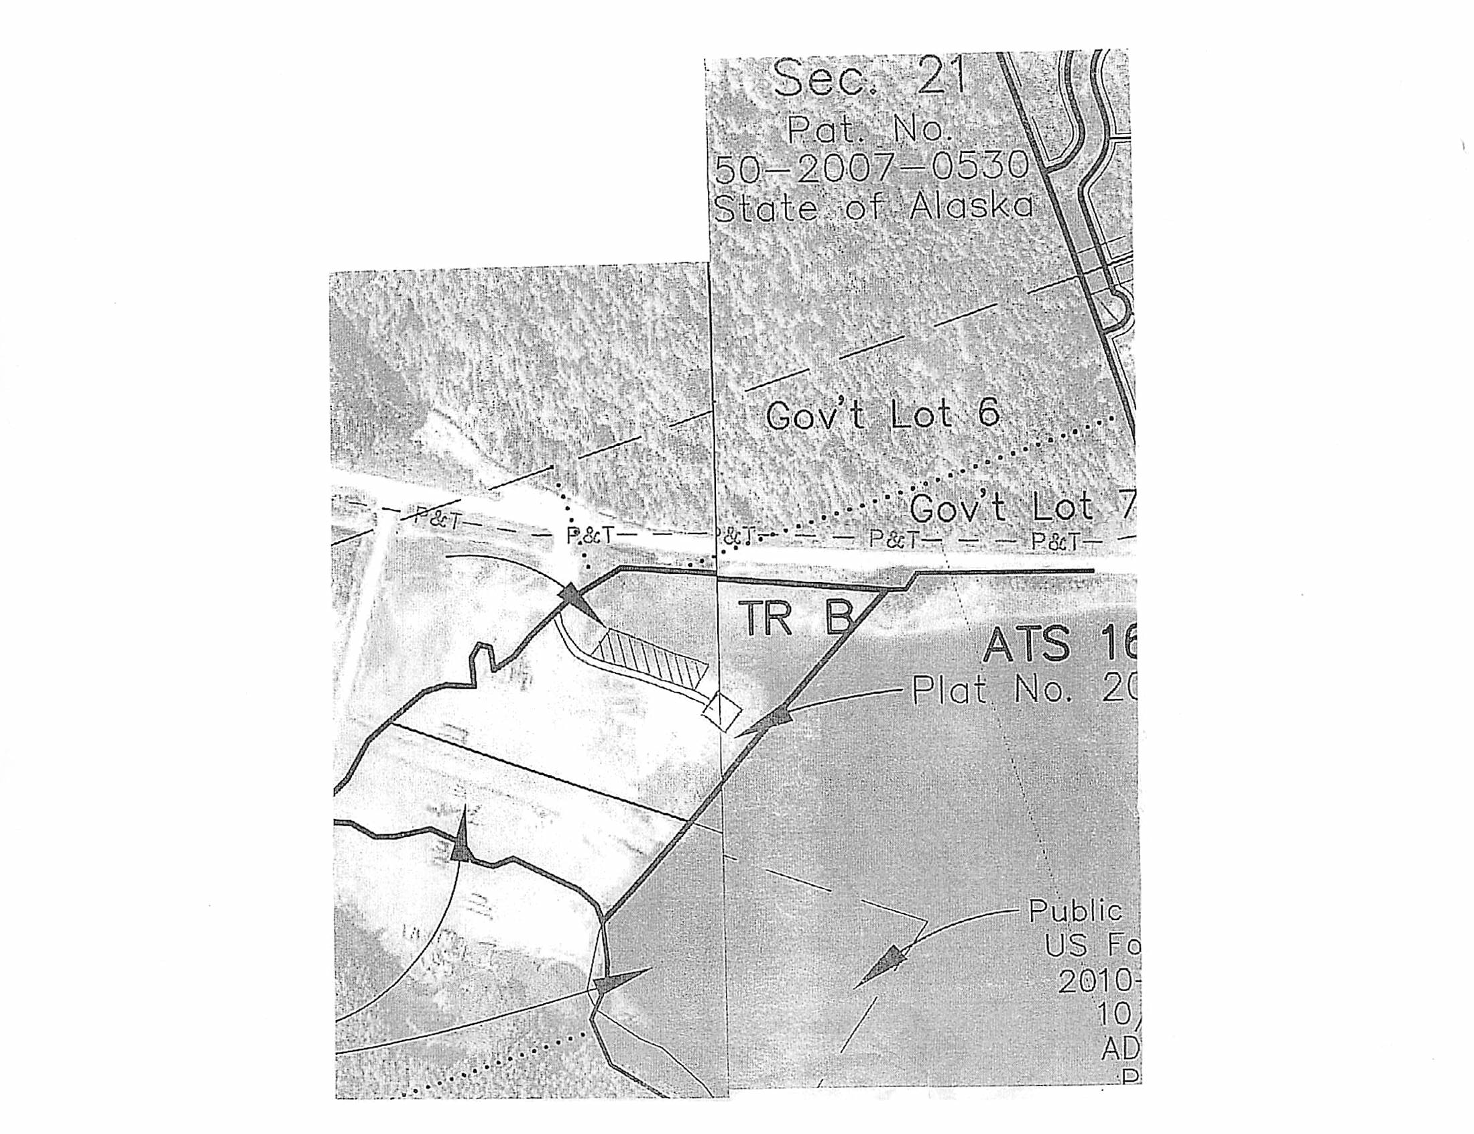

This Rental Agreement is entered into by and between the City of Thorne Bay, Alaska, P.0. Box 110, Thorne Bay, Alaska 99919 (hereinafter called the "CITY "and, Papac Alaska Logging, Inc., (hereinafter called the "RENTER").

- Rented Premises. The City does herby Rent to the Renter one (1) acre plus or minus of land at the Sort Yard on municipally owned property within the corporate boundaries of the City of Thorne Bay.

Municipal Code, Title 2, Article Ill, Incorporated. The provisions of "Title 2, Article Ill of the Thorne Bay Municipal Code shall apply to the terms of this Rental Agreement unless otherwise amended in this Rental Agreement.

- Term. The term of this Rental Agreement shall be Two (2) year(s) beginning June 1. 2018 and ending June 30, 2020 . Monthly rental payments due the City shall commence prior to use of Rented Premises and continue throughout the term of this Rental Agreement. Monthly Sales Taxes due the City shall commence upon the signing of Rental Agreement. Renter shall have the option to renew this Rent for an additional period of time subject to renegotiations of Rent terms and payments acceptable to both the City and Renter. The option to renew and Rent for the additional period can only be effective upon approval by the Thorne Bay City Council. This option to renew shall be e)<ercised by the Renter in writing sixty (60) days prior to the expiration of the original Rent term. The option to renew is specifically waived if not exercised in full compliance with this provision.

This Rental Agreement expires automatically on the last day of the Two (2) year period absent the approval of a new Rental Agreement by the Thorne Bay City Council. Absent an approved Rental Agreement the Renter shall vacate the premise on or before the ending date of this Rental Agreement.

In addition to any rights of the City to terminate this Rental Agreement as specified in this Rental Agreement, or as specified in the Thorne Bay Municipal Code, the City shall have all rights to terminate this Rental Agreement in accordance with any provision of applicable law.

- Monthly Rent Payment. Renter covenants and agrees to pay City monthly Rent payments in the sum of One Hundred Fifty Dollars ($150) plus applicable sales tax payable in advance on the first day of each month of the Rent term. In the event any payment required to be made pursuant to this Rental Agreement is more than ten {10) days past due, a late charge equal to ten percent {10%) per annum on such past due amount will be assessed and charged to Renter by City. At the expiration of two year term the monthly Rent payment shall be reviewed and adjusted in accordance with the provisions of Section 2.56.210 of Title 2, Article Ill of the Thorne Bay Municipal Code.

Page 1 of 8

- Deposits. Renter shall deposit with the City an amount equal to
N/A . Upon termination of the Rental Agreement the Renter shall vacate the premise leaving it in the same clean condition as presented at the time said Rental Agreement was initiated. If the premise is in need of cleaning, repairs or the Renter is in default in payments said deposit shall be used to offset such costs. In the event the Rented Premise is clean and in need of no repairs the deposit will be refunded in full. First and last month may be waved in lieu of improvements to the Rented Premises or other City Facilities as provided by Renter per "Exhibit A".

- Use. Renter shall use the Rented Premises for the purposed of maintaining and operating there on, Storing and working on heaw equipment used for logging and road building . The Rented Premises shall be used for no other purposes without the prior written consent of City.

·6. Utilities and Fees. Renter shall be responsible for all utility accounts and applicable deposits for said accounts. Renter agrees to pay, and keep current, ALL charges, including deposits, for all utilities, including but not limited to water, sewer, refuse collection, electricity, propane, fuel oil and telephone. Failure to do so will result in the utility being shutoff. Activation of a city shutoff shall constitute a material breach of the Rent Agreement resulting in the City's termination of the Rent Agreement. Absent an approved Rental Agreement the Renter shall vacate the premise immediately.

- Repairs, Maintenance and Compliance with Laws. Renter shall maintain the Rented Premises at Renter's sole cost and expense and at all times keep the Rented Premises neat, clean and in a sanitary condition. Renter shall keep and use the Rented Premises in accordance with applicable laws, ordinances, rules, regulations and requirements of all governmental authorities. Renter shall permit no waste, damage or injury to the Rented Premises. Renter's use of the Rented Premises in violation of any law or regulation of any governmental entity related to public health or safety or environmental pollution shall be a material breach of the Rental Agreement and grounds for City's termination of the Rental Agreement. Renter is required to obtain building permit authorization from the City for construction of any and all structures placed on or in the Rented Premises.

- Signs, Alterations and Improvements. All signs or symbols placed on or about the Rented Premises shall be subject to City's prior written approval. After prior written consent of City, Renter may make alterations and improvements to the Rented Premises, at Renter's sole cost and expense. City may elect to require Renter to remove any such alterations and improvements upon termination of this Rental Agreement at Renter's sole cost and expense. Any of Renter's improvements remaining on the Rented Premises longer than thirty (30) days after Renter's possessors rights to the Rented Premises have expired shall become Rented Premises of City.

Page 2 of 8

- Insolvency. In the event Renter becomes insolvent, bankrupt or if a receiver, assignee or other liquidating officer is appointed for the business of Renter, City, in City's sole discretion may immediately terminate this Rental Agreement and require that Renter vacate the Rental Premises.

- Subletting or Assignment. Renter shall not sublet the whole or any part of the Rented Premises nor assign this Rental Agreement without the prior written consent of City. This Rental Agreement shall not be assignable by operation of law. All terms and conditions of the Rental Agreement shall be binding upon any sub Renter or assignee of this Rental Agreement and Renter shall remain fully responsible to City for performance of this Rental Agreement.

- Permits and Compliance with Law. Renter shall obtain all necessary local, state and federal permits necessary for the operation of Renter's business and shall comply with all local, state and federal laws, rules and regulations.

Failure to comply with any requirements of this section shall constitute a material breach of the Rental Agreement. Failure to remedy the violation within 30 days will result in the City's termination of the Rental Agreement. Absent an approved Rental Agreement the Renter shall vacate the premise immediately.

- Insurance. General Liability Insurance: The Renter shall procure and maintain during the life of this agreement, General Liability Insurance on an "occurrence basis" with limits of liability not less than $1,000,000 per occurrence and /or aggregate combined single limit, personal injury, bodily injury and property damage.

Proof of Insurance shall be provided to City within thirty (30) days after the parties have executed this agreement and prior to public use of said premises. City shall be notified at least thirty (30) days before the cancellation or termination of any policy.

City shall be named as additional insured.

- Accidents and Liability. City or its agent shall not be liable for any injury or damage to the persons or property sustained by Renter or others, in and about the Rented Premises.

- Indemnification and Waiver of Subrogation. To the fullest extent permitted by law, the Renter agrees to defend, indemnify and hold harmless the City, its elected and appointed officials, employees and volunteers against any and all liabilities, claims, demands, lawsuits, or losses, including costs and attorney fees incurred in defense thereof, arising out of or in any way connected or associated with this agreement.
To the extent permitted by law, the Renter hereby re-Rents the City, its elected and appointed officials, employees and volunteers from any and all liability or responsibility

Page 3 of 8

to the Renter or anyone claiming through or under the Renter by way of subrogation or otherwise, for any loss or damage to the property caused by fire or any other casualty, even if such fire or other casualty shall have been caused by the fault or negligence of the City, its elected or appointed officials, employees or volunteers. This provision shall be applicable and in full force and effect only with respect to loss or damage occurring during the time of the Renter's occupancy or use.

Renter understands that the City accepts no responsibility whatsoever for loss of, or damage to Renter's property.

- Removal of Renter's Property and Repair of Rented Property. All buildings, fixtures and equipment of whatsoever nature, that Renter shall have acquired and installed upon Rented premises, whether permanently affixed or otherwise, shall continue to be the property of the Renter and must be removed by the Renter at the expiration or termination of this Rental Agreement; and at its own expense, Renter shall repair any injury to Rented Premises resulting from such removal. Renter shall remove all buildings, fixtures, and equipment, and make all repairs, within thirty days of the date the Renter vacates Rented Premises. If the Renter fails to remove its buildings, fixtures, and equipment, and fails to make the necessary repairs, the City may do so, and seek reimbursement from the Renter for the full amount of the repairs, without any deduction for the value of any buildings, fixtures, or equipment left on the premises by the Renter. If City determines that it is in City's best interest to acquire the improvements, it may negotiate to purchase Renter's buildings, fixtures, and equipment at a price equal to or less than fair market value.

- Taxes. Renter shall be solely and fully responsible for the payment of all applicable federal, state, and Thorne Bay municipal taxes including all Monthly Sales Taxes due the City.

- Liens. Renter shall maintain Rented Premises free of any and all liens. Renter will not permit any mechanics', laborers' or materialmen's liens to stand against the Rented Property or improvements for any labor or materials furnished to Renter or claimed to have been furnished to Renter, or to Renter's agents, contractors, or sub-Renters, in connection with work of any character performed or claimed to have been performed on Rented premises or improvements by or at the direction or sufferance of Renter; provided, however, Renter shall have the right to contest the validity or amount of any such lien or claimed lien, In the event of such contest, Renter shall give to the City such reasonable security as may be demanded by the City to insure payment of such lien or such claim of lien. Renter will immediately pay any judgment rendered with all proper costs and charges and shall have such lien re-Rented or judgment satisfied at Renter's own expense. Renter agrees to indemnify, hold harmless and to defend the City and Rented premises from such liens. Renter consents to the City's recording of and posting of a statutory notice of non-responsibility in accordance with Alaska Stature 34.35.065

Page 4 of 8

- Default by Renter. Each of the following shall be deemed a default by the Renter and a breach of the Rental Agreement:
  - A failure to make payment of ny installment, of rent or of any other sum herein specified to be paid by Renter, and Renter fails to cure such default within ten (10) days after receipt of a written notice has been received by Renter-specifying such failure to make payment;
  - Upon shut off of utilities;
  - A default in the performance of any other covenant or condition on the part of the Renter to be performed for a period of thirty (30) days after receipt by Renter of a notice specifying the particular default or defaults;
  - The filing of a petition by or against Renter for adjudication as a bankrupt, or for reorganization or arrangement within the meaning of the Bankruptcy Act;
  - The dissolution or the commencement of any action or proceeding for the dissolution or liquidation of the Renter or for the appointment of a receiver or trustee of Rented Premises of the Renter;
  - The taking possession of Rented Premises of the Renter by any governmental officer of agency pursuant to statutory authority for the dissolution of liquidation of the Renter;
  - The making by the Renter of an assignment for the benefit of creditors;
  - Renter vacates or abandons the Rented Premises; and
  - A failure that continues for five (S) days or more to have the City named as an additional insured as required under paragraph 18, and Renter fails to cure such default within ten (10) days after receipt of a written notice has been received by Renter specifying such failure to name the City as an additional insured.

The specification of events constituting default by the Renter in this Section, are in additional to any defaults specified in the Thorne Bay Municipal Code.
- City's Remedies for Default. In the event of any default of the Renter, the City shall have the following rights and remedies - all in addition to any rights or remedies that may be given to the City by statue, common law, or under Thorne Bay Municipal Code.
  - Distraint for rent due and subsequent sale of chattels so distrained. The sale of any such chattels shall be in accordance with the procedure set forth in Alaska Statues.
  - Re-enter Rented Premises and take possession thereof, remove all persons therefrom, and remove Renter's property therefrom and store it in a public warehouse or elsewhere at the cost of Renter, all without service of notice or resort to legal process (all of which Renter expressly waives) and without becoming liable for trespass, forcible entry, detainer, or other tort or for any loss or damage which may be occasioned thereby;

Page 5 of 8

  - Declare the Term ended;
  - Re-let Rented premises in whole or in part for any period equal to or greater, or less, than the remainder of the Term for any sum which is commercially reasonable;
  - Cure any such default, if possible, and demand immediate payment until all costs incurred in curing the default have been reimbursed fully, together with interest calculated at the rate of ten percent (10%) per annum at the then current prime rate as established by the First Bank of Alaska;
  - Collect all reasonable damages, costs and expenses that the City may incur by reason of default by Renter, together with interest calculated at the rate of ten percent (10%) per annum at the then current prime rate as established by the First Bank of Alaska.
  - The City shall use reasonable diligence to relet Rented Premises in or to mitigate the City's damages, consistent with the uses of Rented Premises, and all applicable Thorne Bay code provisions related to this Rent and Rented Premises.

- Rights and Remedies. Except insofar as this is inconsistent with or contrary to any provision of this Rent, no right or remedy herein conferred upon reserved to the City or Renter is intended to be exclusive of any other right or remedy, and each and every right and remedy shall be cumulative and in addition to any other right or remedy given hereunder, or now or hereafter existing al law or in equity or by statute.

- Waiver. Except to the extent that a party may have otherwise agreed in writing, no waiver by a party of any breach by the other party of any of its obligations, agreements or covenants hereunder shall be deemed to be a waiver of any subsequent breach of the same or any other covenant, agreement or obligation. Nor shall any forbearance by a party to seek a remedy for any breach of the other party be deemed a waiver of its rights or remedies with respect to such breach.

- Changes. No modifications, amendments, deletions, additions or alterations of the Rent Agreement shall be effective unless in writing and signed by all of the parties hereto and such representatives of the parties as have been duly authorized to make such changes.

- Joint Product. The language set out in this Rental Agreement represents the joint product of the parties and shall not be construed against one party in favor of the other. Each party hereto has had the option of seeking the advice of legal counsel in the drafting of this Rental Agreement, and the rule of construction favoring construction against the draftor shall not apply. Renter acknowledges and agrees that Renter has not received any legal advice from the City's attorney or from anyone associated with the City.

- Authority. The parties and their undersigned representatives warrant that they have full authority to enter into this Rental Agreement and to execute this Rental Agreement.

Page 6 of 8

- Hazardous Materials. The Renter shall not permit, store, manufacture or dispose on Rented Premises any hazardous material or controlled substance as determined by federal, state, or municipal statures or laws now or at any time hereafter in effect, including but not limited to, the Comprehensive Environmental Response, Compensation and liability Act {42 U.S.C. 9601 et seq.), the Hazardous materials Transportation Act (42 U.S.C. 1801et seq.), the Resource Conservation and Recovery Act (42 U.S.C. 6901 et seq.), the Federal Water Pollution Control Act (33 U.S.C. 1251 et seq.), the Clean Air Act (42 U.S.C.7401 et seq.), the Toxic Substance Control Act, as amended (15 U.S.C. 2601 et seq.), and the Occupational Safety and Health Act {29 U.S.C. 651et seq.), and Title 46 of the Alaska Statutes as these laws have been and may hereafter be amended or supplemented. "Hazardous Substance" means any pollutant, contaminant, toxic substance, flammable, explosive, radioactive material, urea formaldehyde foam insulation, asbestos, PCB's or any other substance the removal of which is required, or the manufacture, preparation production, generation, use maintenance, treatment, storage, transfer, handling or ownership of which is restricted , prohibited, regulated or penalized by any and all federal, state, or municipal statutes or laws now or at any time hereafter in effect. Hazardous material shall not include cleaning supplies used in the routine daily cleaning and operation of a restaurant.

- Acceptance of the Rented Property by Renter. Renter acknowledges that it has thoroughly examined Rented Premises. Renter accepts Rented Premises in their "AS IS" condition, and the City shall not be required to perform any work to prepare Rented Premises for the Renter. Renter's taking possession of Rented Premises shall be conclusive evidence against it that, at the time possession was taken, Rented Premises were in good and satisfactory condition. Renter acknowledges that, except for those representations and statements regarding the condition of Rented Premises expressly stated herein, Renter has not relied upon any representations or statements of the City or its representatives or agents regarding the condition of Rented premises or their suitability for Renter's uses under this Rent.

- Attorneys' Fees and Costs. Should any dispute and/or legal action arise by reason of any default or breach on the part of Renter in the performance of any ofthe provisions of the Rental Agreement, Renter agrees to pay all reasonable attorneys' fees and costs incurred by City in connection therewith including City's attorneys' fees and costs incurred on appeal. It is agreed that the venue of any legal action brought under the terms of this Rental Agreement will be the First Judicial District, at Ketchikan, Alaska. Renter specifically agrees that venue for trial in any action related to this Rent shall be in Craig, Alaska.

- No Waiver of Covenants. Any waiver by either party of any breach hereof by the other shall not be considered a waiver of any future or similar breach. This Rental Agreement contains all the agreements between the parties, and there shall be no

Page 7 of 8

modification of the agreements contained herein except by written instrument signed by both parties.

- Surrender of Rented Premises. Upon termination of this Rental Agreement, Renter agrees to peacefully quit and surrender the Rented premises without notice, remove all of Renter's personal property and leave the Rented premises neat and clean. If City elects to require Renter to remove any alterations or improvements made by Renter, then Renter shall restore the Rented Premises to their previous condition, at Renter's sole expense.

- Binding on Heirs, Successors and Assigns. The covenants and agreements of this Rental Agreement shall be binding upon the heirs, executors, administrators, successors and assigns of both parties thereto, except as hereinabove provided, and as allowable by law.

- Notice. Any notice required to be given by either party to the other shall be deposited in the United States mail, postage prepaid, addressed to City at P.O. Box 19110, Thorne Bay, Alaska 99919, or the Renter at, PO Box 404, Craig, AK 99921, or at such other address as either party may designate in writing to the other.

- City's Right of Entry. The City shall have the right to enter Rented premises at all reasonable times to examine the condition of same.

IN WITNESS WHEREOF, The parties hereto have executed this Rental Agreement as of the date first set above written.

CITY: RENTER:

THE CITY OF THORNE BAY

By Harvey McDonald, Mayor "City"
By
Papac Alaska Logging, Inc. "Renter"

ATTEST:

Teri Feibel, CMC

Page 8 of 8

CITY OF THORNE BAY RESOLUTION 18-06-05-01

A RESOLUTION OF THE CITY COUNCIL FOR THE CITY OF THORNE BAY, ALASKA, REPEALING RESOLUTION 16-10-10-01; THAT PLACED A 21-DAY LIMIT ON RV PARK OCCUPANCY

WHEREAS, the City Council is the governing body for the City of Thome Bay, Alaska; and

WHEREAS, the City of Thome Bay owns and manages the RV Park; and

WHEREAS, the City evaluated the daily, weekly and monthly uses at the RV Park as to whether it is prudent to continue operating an RV Park in the present location; and

WHEREAS, the City evaluated the infrastructure, including power that services the RV Park and determined it was in the best interest of the City to expand the RV Park and upgrade the electrical to accommodate both short term transient occupants, as well as monthly occupants.

NOW THEREFORE BE IT RESOLVED that the City Council for the City of Thorne Bay, Alaska, effective immediately repeals Resolution 16-10-10-01; and removes the 21-day limit that was placed on RV Park occupants.

PASSED AND APPROVED June 1, 2018

Harvey McDonald, Mayor

ATIEST:

Teri Feibel, CMC

CITY OF THORNE BAY
R ESOLUTIO N 16-10-10-01

A RESOLUTION OF THE CITY COUNCIL FOR THE CITY OF THORNE BAY, ALASKA, TEMPORARLY LIMITING THE RV PARK USAGE

WHEREAS, th e City Cou nc il is the governing body for the City of Th orn e Bay, Ala s ka ; a nd

WHEREAS, the City of Thorne Bay owns and manages the RV Park; and

WHEREAS, the City needs to eva lua te the daily, wee kly and monthly uses at the RV Park as to whether it is prudent to continue operating an RV Park in the present loca tio n; a n d

WHEREAS, the City need s to evaluate the infrastruclure, including pov1,e r Lhat se rvices the RV Park as the infrastructure was in it ia lly in s ta lled to serve short term seasona l use; and

WHEREAS, the RV Park has become rental lots for permanent livin g; and

WHEREAS, the RV Park has become a disposal grounds for unwanted motorhomes a nd trailers.

NOW THEREFORE BE IT RESOLVED that Lhe City Council for the Cily of
Th orn e Bay, Ala s ka , effective immed ia tel y limit usage of the RV Park lo 21 days or less following the same format the Fores t Service imposes upon it's Recreational Vehicle users until the City Council has had time to re-evaluate how Lhe RV Pa r k will co ntin ue to be used.

PASSED AND APPROVED October 10, 2016
q;: ¼-0

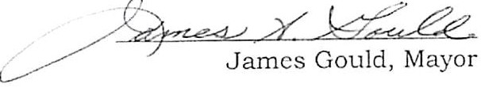

eri Feibel, CMC

CITY OF THORNE BAY, ALASKA RESOLUTION NUMBER 18-06-05-02

A RESOLUTION REQUESTING: USDA'S INSPECTOR GENERAL TO: (1) CON­ DUCT A FORENSIC AUDIT OF THE TONKA AND BIG THORNE INTEGRATED RESOURCE TIMBER CONTRACTS, AND (2) RESTORE PAYMENT OF FUNDS THAT THE AFFECTED COMMUNITIES SHOULD HAVE BENEFITED FROMi

WHEREAS, the 2016 Washington Office Activity Review (WO Review) investigated exe­ cution of the Tonka and Big Thorne Integrated Resource Timber Contracts on the Peters­ burg and Thorne Bay Ranger districts of the Tongass National Forest and made im­ portant formal findings and recommendations; and,

WHEREAS, the WO Review findings of fact revealed systematic failures in the admin­ istration, monitoring, and enforcement of the above timber contracts; and,

WHEREAS, the WO Review's findings of fact and supporting documentation reveal that several millions of dollars of revenue from the· above timber contracts - amounting to nearly $2 million for the Tonka contract and $1.7 million for the Big Thorne contract­ were not collected due to misadministration or maladministration of the contracts; and,

WHEREAS, those uncollected revenues entail significant losses to the City of Thorne Bay and City of Thorne Bay, because revenues that would have been generated from In­ tegrated Resource Timber Contracts on the Petersburg and Thorne Bay Ranger districts would fund local businesses to implement restoration and stewardship projects; and,

WHEREAS, the WO Review recommended "an independent review [to] inform solutions
- and prevent similar issues in future timber and stewardship contracts" (emphasis added), yet no apparent, meaningful action has been undertaken by the agency during the nearly two years since the Review was conducted; and,

WHEREAS, unless the Washington Office's recommendations are fully followed, the Central Tongass and Prince of Wales Landscape Level Analyses - which the agency is planning and which will result in timber sales - will also result in monetary losses to the both agency and local governments;

- 1 of 2 -

Resolution #18-06-05-02

THEREFORE, BE IT RESOLVED, the City of Thorne Bay, Alaska requ sts that:

the USDA Inspector General to conduct a forensic audit of the Tonka and Big Thorne Integrated Resource Timber Contracts to determine: (a) the amount of money the For­ est Service should have collected from the timber contracts, (b) why those funds were not collected and what misadministration or maladministration occurred, and (c) the amount of money that should have been available for restoration and stewardship projects recovered; and

- Rep. Don Young and Sen. Lisa Murkowski to find out whether the Inspector General has sufficient funds to conduct that audit, and that they secure such additional funds as may be needed; and

PASSED AND APPROVED this 5th Day of June 2018, by a duly constituted quorum of the Thorne Bay City Council

Harvey McDonald, Mayor

ATTEST:

Teri Feibel, CMC

Cc:

Dave Zimmerman, Petersburg District Ranger
Matt Anderson, Craig District Ranger Tyler Gunn, Thorne Bay District Ranger Earl Stewart, Tongass Forest Supervisor

Vickie Christiansen, Interim Chief of the USFS Regional Foresters Beth Pendleton and David Schmid Rep. Don Young
Senator Dan Sullivan Senator Lisa Murkowski
Rep. Jonathan Kreiss-Tompkins Senator Bert Stedman

- 2 of 2 -

Resolution #18-06-05-02

http: //www.eenews.net/eenewspm/stories/ 1060052518

E&ENewsPM

Late-Breaking News

Green group asks IG to probe Tongass timber sales
Scott Streater, E&E News reporter I E&E PM I April 3, 2017
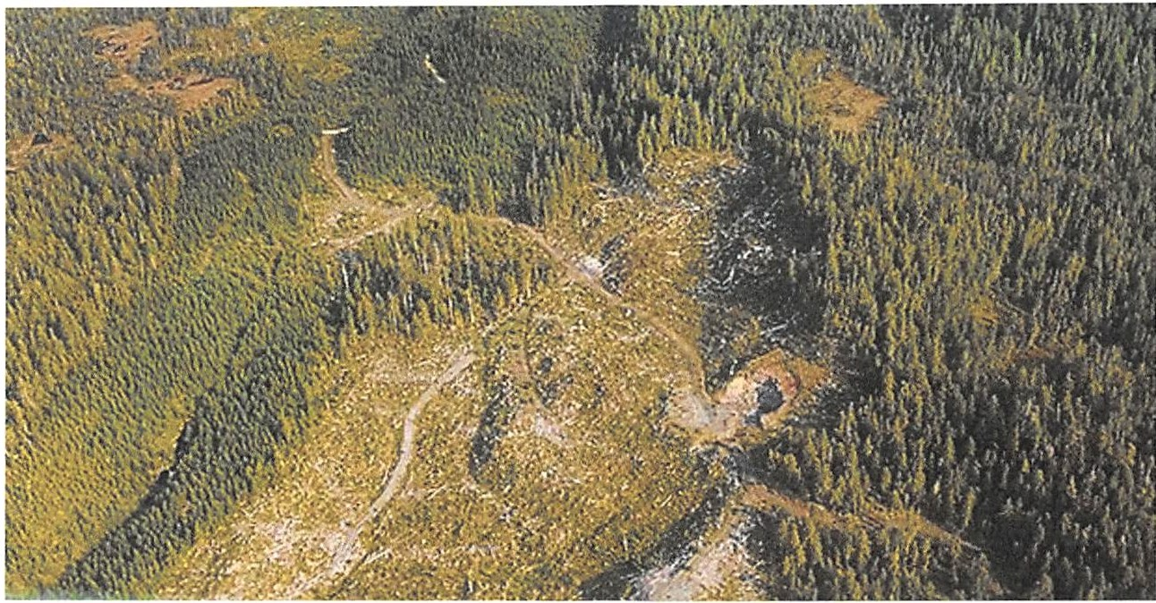
A clearcut section of Tongass National Forest Photo by Alan Wu, courtesy of Flickr.

A government watchdog group says poor oversight by the Forest Service of two large timber sales in Alaska's Tongass National Forest resulted in "staggering monetary losses" that hurt local communities and the nation's largest forest.

Public Employees for Environmental Responsibility, or PEER, says the Forest Service allowed contractors at the two 2015 timber sales to cherry-pick the trees they wanted to remove without much oversight. As a result, more valuable western red cedar and Sitka spruce trees were cut and removed, while most of the white hemlock that the service wanted removed in the name of forest health was left standing, the group charged.
The Forest Service missed out on close to $4 million it should have collected based on the value of the timber extracte d, PEER alleged today in a letter to Agriculture Department Inspector General Phyllis Fong, requesting that the IG "conduct a forensic audit to determine the true extent oflosses to the taxpayer."
Also today, PEER submitted a separate letter asking Senate Agriculture, Nutrition and Forestry Chairman Pat Roberts (R-Kan.) and ranking member Debbie Stabenow (D-Mich.) that before the committee confirms the next Forest Service chief and other top USDA officials, they get the nominees to commit that they will "ensure that all future timber sales protect both the forest resources and the taxpayer's pocketbook."

"Despite being stewardship sales to improve forest health, the agency allowed companies to ignore prescriptions by 'favoring removal in the larger diameter, more valuable species groups, such as western red cedar and spruce' while significantly undercutting far less valuable hemlock," according to the letter signed by PEER Executive Director Jeff Ruch.
"In short, we are asking you to take steps to ensure that new leadership in and overseeing the [Forest Service] are committed to ensuring that future sales yield the fair market value they are supposed to produce and protect the forest resource," Ruch's letter concludes.
In the letter to Fong, Ruch said undervaluing timber sales and not collecting the money owed to the federal government harmed local communities near the national forest in southeast Alaska.
The Secure Rural Schools and National Forest Receipts programs require that "a portion of all Tongass timber sale proceeds go to local communities and schools. Depressed sale values therefore cost both the
U.S. taxpayers and Alaskan schoolkids. PEER is also asking you to determine if there [is] any
mechanism for recovering funds rightfully owed to both the [Forest Service] and the Alaskan communities and schools."
A Forest Service spokeswo man said the agency could not comment on this story by publication time.
One of the timber sales - the Big Thome timber project - was designed to provide "bridge timber" to allow mills to stay in business until more second-growth trees are old enough to cut.
The project was the subject of a lengthy court battle, with the 9th U.S. Circuit Court of Appeals in early 2015 denying a request by environmental groups to halt the timber sale ( Gre enwire, April 17, 2015).
PEER, in its requests to the Senate and IG, focused on the agency's Washington Forest Management Activity Review of timber sales and stewardship contracting across the Forest Service's Region 10.
The review found that the Forest Service did not provide proper oversight of the two timber sales and that companies removed far more valuable species than contracted.
PEER points to a post-harvest monitoring report that found during one sale, far less of the white hemlock that the Forest Service wanted removed was actually harvested.
That report says that for the second timber project, called the Tonka timber sale, "only 14.2" percent of the white hemlock was removed, compared with 90 percent of Sitka spruce and 84 percent of Alaska yellow cedar.
The review noted that the Forest Service could not "produce a written contract or other 'pertinent documentation' for this high-volume sale," among other problems.
"This national forest runs major commercial timber sales like a cookie jar without a lid," Ruch said.
He also said that the Forest Management Activity Review's call for "an independent review [to] inform solutions and prevent similar issues in future timber and stewardship contracts" has run into what PEER called a stonewall.
Email: sstreater@eenews.net

2

Beebe"Testimony Petersburg Borough 4 Ap\f.- 2018

Hi my name is David Beebe, I am representing myself and all members of the tax paying public concerned about the state fiscal crisis and the federal deficit as it relates to funding the schools and roads of the Petersburg Borough.

It's highly likely that most Assembly members have been unaware of the details of the leaked agency documents of the USFS Washington office review, or the Findings of fact relating to the Petersburg Ranger district in its maladministration of the Tonka timber sale. I'll read just one portion of the findings of that report. (I quote), 1 rhe cost of not inspecting and not following the contract and the (NEPA) prescriptions was close to $2 million..."

That's $2 million which would have gone to the Petersburg school District, and borough roads through Secure Rural Schools funding while we are in the midst of a state fiscal crisis.

I would now like to provide for the assembly a News report of last December 2017 detailing an identical circumstance on the Francis Marion National Forest io South Carolina, 1 What is most striking about this report is the identical pattern of maladministration and failure of the agency to investigate, and hold accountable the perpetrators which allowed what appears to be large-scale timber theft occurring to the detriment of local communities.

If there is anything to draw from these identical circumstances whether it's on the Petersburg Ranger district of the Tongass or the Francis Marion National Forest, is that the existing agency culture is institutionally incapable of holding its employees and line officers personally, and professionally accountable for maladministration resulting in millions of dollars of losses to communities.

In conclusion I am requesting the assembly draft a resolution requesting sufficient funding to allow for an independent investigation by the Inspector General to review what happened on the Petersburg Ranger district and Thorne Bay Ranger district.

Finally, I'd like to hear from the mayor if this matter of maladministration was discussed in the recent Washington DC trip lobbying for Secure Rural Schools funding. My concern is the assembly might think that this recent infusion of money would suggest that "the fix is in," but unfortunately this is merely treating just a symptom of the larger Agency problem. That cannot be fixed until an independent investigation occurs, and the agency and the individual perpetrators are held accountable.

Thank you for this opportunity to speak to this matter.

1 http://www.counton2.com/news/call-collett-tons-of-trees-cut-illegally-on-public-lands­ represents-loss-of-government-revenue/1031563768

1 -

WO-Forest Management Activity Review
Alaska Region, June 12-20, 2016 06282016 Page 1 of20

WASHINGTON OFFICE ACTIVITY REVIEW OF
TIMBER SALE ADMINISTRATION, SALE PREPARATION, STEWARDSHIP CONTRACTING, NEPA AND TIMBER THEFT PREVENTION
REGIONlO June 12-20, 2016
REPORT
USDA FOREST SERVICE WASIDNGTON, D.C.

!l!!i!
REVIEWTEAM

Position

Carl Maass JoeReddan
Team Leader, WO-FM, Sale Administration Contract Specialist
Assistant Director for Forest Products,
WO-FM
Contract and Appraisal Specialist
Organizational Effectiveness

Richard Aubuchon Appraisal Specialist, WO-FM Sale Preparation and
Appraisal

Margo Langley National Timber Sale Accounting Timber Sale
leader, WO-FM Accounting
Beth Boddiger National TIM group leader, WO-FM Sale preparation and
Data Management Justin Humble WO-Engineering Specialist Engineering and
roads
Martin Moeller R6 & 10 Roads Engineer Engineering and roads
Brett Roper WO-Watershed, Fish, Wildlife, Air, Wildlife, Fish and and Rare Plants (WFWARP) NEPA
Megan Healy WO-Ecosystem Management Planning and NEPA Coordination

Scott Heine Special Agent, LE&I, R9 Accountability

WASHINGTON OFFICE ACTIVITY REVIEW TIMBER SALE ADMINISTRATION, SALE PREPARATION,
STEWARDSHIP CONTRACTING, NEPA AND THEFT PREVENTION
REGION 10 - Alaska 2016

Tablf of Contents
- INTRODUCTION 3
Type of Review 3
Need for Review 3
Review Objectives and Major Areas of Emphasis 3
Review Approach 4
- COMMENDATIONS 4
- FOLLOW UP TO ACTION ITEMS FROM 2001 ACTIVITY REVIEW 5
- ISSUES AND FINDINGS 6
ISSUE 1: Financial Issues 6
ISSUE 2. Need For Accountability and Compliance with the Regional Timber Theft Prevention Plan 8
ISSUE 3: Engineering portions and administration of the Big Thome Stewardship Contract did not meet standards 8
ISSUE 4: The Big Thome Project did not follow national policy in implementing the Gate System 9
ISSUE 5: Use of Designation by Prescription (DxPRE) is not following direction or achieving results as described in the provision.......................................................................I0
ISSUE 6: Temporary Roads are Left Open 13
ISSUE 7: Region's appraisal program does not reflect the latest selling values 13
- OBSERVATIONS 14
- CONCLUSIONS 18
APPENDIX A: ITINERARY FOR THE REVIEW 20

FOREST MANAGEMENT ACTIVITY REVIEW REGION l 0- ALASKA
June 12-20, 2016

- iNTf ODUCTION

Type of Review

A Forest Management Activity Review focusing on timber sale and stewardship contracting ctivities in Region 10, including preparation, administration, and timber theft prevention was conducted from June 12-20, 2016. The review team examined and evaluated regional guidelines, program direction, accounting procedures, and accomplishments at the regional office and forest level. The Forest Service internal review system guidelines (FSM 1410) were used to conduct this review.

Need for Review

Preparation and administration of timber sale and stewardship contracts are key areas of resource management and critical for the attainment of resource objectives. National Environmental Policy Act (NEPA) disclosure, decision implementation, and theft of timber from National Forest System land continues to attract national attention. The last similar review in Region IO was completed in 2001. A limited review of the transaction evidence appraisal (TEA) system was conducted in 2003. A functional assistance trip was conducted in 2013 to discuss the residual value appraisal system being used. The intent of this review is to follow up on these past findings and recommendations to determine where progress has been made and identify any areas that continue to need attention.

Review Objectives and Major Areas of Emphasis

  - Evaluate compliance with national policies and directions pertaining to preparation and administration of timber sale and stewardship contracts, delegations of authority for timber disposal, NEPA decision implementation, and timber theft prevention procedures
  - Follow up on Action Items from 2001 Activity Review and 2013 Functional Assistance Trip conducted by the Washington Office (WO) including use of timber information manager (TIM), timber sale accounting, and the appraisal system

  - Evaluate implementation of authorities from the 2014 Farm Bill including stewardship, Good Neighbor Authority, and designation by prescription

  - Evaluate implementation of silviculture prescriptions for consistency with land management objectives and NEPA decisions

  - Review implementation of NEPA decisions and monitoring during timber sale and stewardship contract preparation and administration
  - Evaluate the adequacy and effectiveness of the organizational structure and the coordination of the forest management program at all levels

  - Evaluate the training and skill level of forest management program employees
  - Evaluate regional and forest training and certification programs related to sale preparation and sale administration
  - Evaluate the management controls for log accountability and payments
I 0. Evaluate the management controls for sale appraisal, contract preparation, permit issuance, and reporting
11. Evaluate implementation of national policy and standards regarding transportation planning, road maintenance, and construction methods

Review Approach

The review was conducted on the Tongass National Forest and included the review of the Big Thome timber sale and to a lesser extent the Tonka Integrated Resource Timber Contract (IRTC) stewardship contracts. This review covers office records, discussion with field personnel, and observation of procedures applied on the ground. Dave Harris, Director for Forest Management in Region 10, served as the review team liaison responsible for coordinating the Region's interdisciplinary participation in the review, arranging for review of materials and travel within the Region. An in-person closeout report was provided with findings and observations before the team left on Monday, June 20, 2016, which was followed by a final written report after the review.

- Dave Harris provided excellent logistical support for all aspects of this review. The travel and lodging for more than ten individuals by plane, boat, and truck covering four overnight locations and numerous short stops, was extremely challenging and the team recognizes, especially after the fact, how much effort he and his team must have expended to make the trip as flawless as it was.

- Safety was seamlessly incorporated into the review itinerary. Inspections and briefings were conducted sometimes openly, sometimes subtly, personal protective equipment and mandatory pre-flight safety training was provided as appropriate. Dave and his team did an excellent job of mitigating the hazards that are inherently part of doing business in Alaska.

- Dave Harris and his team provided very comprehensive pre-review electronic documentation, which was very useful in preparing for this review.
- Tongass National Forest (NF) and District personnel who participated in the review are commended for providing the team with candid insights and information. Their willingness to speak openly about the issues, challenges, and successes, of which there are many, speaks to the great potential for improving the work environment and team atmosphere across the Tongass NF. There is no doubt that the management team and staff

of the Tongass NF consists of dedicated professionals who are striving against monumental headwinds to achieve the results the public expects.

- In tight of the political pressure and tight deadlines, the Forest should be commended for their ability to complete the project within the timeframe.

Adaptive Management: The Timber Program Review in 2001 found that partial harvest prescriptions failed to adequately identify future vegetation management objectives or options. Should the Forest continue partial cutting and uneven-aged management, the review report recommended developing silviculture prescriptions needed to implement the new strategy including an appropriate update to the forest plan. The 2016 review found that the Forest is following these recommendations.
The Program Review found that non-painted trees in diameter limit prescriptions may not be meeting all resource objectives and recommended that the Region define under what conditions diameter limit prescriptions are to be used. The Region's 2001 Action Plan addressed implementation of this recommendation. The 20I6 review found that the Region has transitioned to partial harvest prescriptions based upon a basal area (BA) removal approach.
Log Accountability: The 2016 review found that the Region is following the recommendations in the review report and in their action plan.
Financial Accountability: The 2001 review found that following a long delay in filling the position dealing with automated timber sale accounting (ATSA) and other business management activities, problems were identified that needed attention. The recommendations were for the Region to identify problems and conduct workshops to train personnel on resolving the problems and to continue functional assistance trips intended to ensure that quality work is being accomplished in a timely fashion. The Region's action plan addressed the recommendations.

The 2016 review found that there continues to be problems with filling vacancies. The combination ofskillsets of those individuals currently in ATSA and other business management activities, the impact of the unfilled regional position, and the normal logistical challenges in the Region is impeding their ability to conduct workshops and functional assistance trips.

B. FOLLOW UP ON RECOMMENDATIONS OF TIMBER SALE APPRAISAL FUNCTIONAL ASSISTANCE TRIP (FAT) (2013)
Overview: The issues identified in this FAT have been or are being addressed. Many of the issues are addressed in the June 2016 direction letter from the Regional Forester to the Tongass NF Supervisor.

Note: An issue is a general description of a subject area containing findings. A finding is an observation of an activity that does not meet policy and needs corrective action to bring it into compliance with national or regional policy. Issues are not listed in order of importance or priority.

ISSUE 1: Financial Issues

FINDING 1: Salvage Sale Fund (SSF) collection plans have been approved for use on the Tonka and Big Thorne Stewardship sales. Distribution of funds to SSF reduces the funds available to support stewardship projects.
DISCUSSION: Deriving receipts from the sale of products designated for removal through stewardship contracting projects is a secondary objective to achieving land management goals. In accordance with 16 U.S.C. 2104 (d)(2)(3) and 2014 Farm Bill, Sec 8205(2)(3) cash receipts realized from stewardship sales are to be used to fund other stewardship projects and are not considered to be monies received from the National Forest System or the public lands under any provision of law.
In accordance with Forest Service Handbook (FSH) 2409.19, 67(l)(c) cash revenue from stewardship projects can only be distributed to the SSF to reimburse the SSF expenditures incurred in preparing the project.
RECO:MMENDED ACTION: Cancel Salvage Sale Plans associated with any stewardship contracts and remove from ATSA if the stewardship projects were not prepared with salvage sale funds.
FINDING 2: Advance Deposit requirements for payment prior to cutting under E.2.1.2 Advance Deposits of the Big Thorne IRTC, are not being met. Advance deposits are only being required for the minimum amount of 30 days, however cutting and hauling operations exceed projected volume and value, resulting in an account balance that consistently falls below the mandatory
10-day cut suspension balance requirement.
DISCUSSION: Contract statement projections do not accurately reflect advance deposit needs, and the review team identified several instances where operations were not adequately covered. No documented evidence of suspension of operations or revised operating plans was found. Lack of adequate coverage of minimum advance deposits is putting the Forest Service and the contracting officer (CO) at risk of financial loss, resulting in personal liability for the CO if payment is not received from the contractor for timber removed.
RECOMMENDED ACTION: Bring projected cut and removal volume and value in line with operating plans and actual production. Require sufficient cash or payment guarantee to cover actual production. Provide additional training on advance deposits and calculating projections. Ensure projections are accurately reported on the monthly statement and billings and collection of advance deposits is timely.

FINDING 3: A complete official contract record was not available. Records are located at multiple locations and while sale preparation documentation was provided from a second location, these files did not include official, signed, hardcopy documents to support the awarded contract.
DISCUSSION: The official contract records are not in compliance with FSH 2409.15 Sale Administration Handbook, Chapter I4 and FSH 6209.11 Records Management Handbook, Chapter 40. The Tongass NF contract records appear to be dispersed between several locations; however, the Forest was unable to provide official approved documents when requested from local offices. One complete official record is not being maintained with the CO. It is critical that the CO maintains a complete record and accurate documentation of all records to administer the contract. Forest Management directives on contract records identify the required documents that should be printed and maintained in hardcopy. For example, the contract record located at the Petersburg Supervisor's Office with the CO did not include pertinent environmental analysis disclosure and decision documents. Financial internal controls also provide for specific documentation requirements found at FSM 6503 POLICY (31 U.S.C. 3512(c), General Accounty Office (GAO)-14-704O Federal Internal Control Standards (pages 47 and 48). Finally, agency records management requires a hardcopy contract record with a 30-year retention.
RECOMMENDED ACTION: Ensure that all pertinent documents are submitted to the CO for printing and filing in a single official contract record.
FINDING 4: No documentation was included in the CO's official files from the Engineering Representative(s) or Construction Inspector.
DISCUSSION: Electronic copies were made available but were still in an editable form (MSWord Document). The last recorded visit to the Big Thorne stewardship sale was in March of 2016.
RECOMMENDED ACTION: Consolidate all engineering inspection reports and any other correspondence into the official file with the CO. Review documentation and project/sale visit requirements in FSH 2409.15, Chapter 10 and regional supplement R-10 2409.15-2006-2. The supplement requires Engineering Representatives to use form RI 0-2400-25a, Timber Sale Inspection Report. If electronic copies of documentation are submitted, place a hard copy in the official file.
FINDING 5: Corporate certifications on various legal instrumer:its, including the stewardship or timber sale contract, are not properly executed.
DISCUSSION: When the legal entity is a corporation, the corporate signature must be certified by a different member of the corporation. Signers cannot self-certify the validity or authenticity of their corporate representation. Also, no witnesses should sign a contract with a corporation as they do not provide any legal certification for the corporate signer. Contracts are not executed properly. Corporation certification is "self-certified."
RECOMMENDED ACTION: Ensure that all legal instruments, e.g. contracts, bonds, etc., are executed by a corporation officer, and are properly certified.

FINDING 6: Project plans, certifications, or other documents that must be signed by a Line Officer under FSM 2404 are being signed by staff identified as signing "for" the Line Officer.
DISCUSSION: Line Officer approval that cannot be re-delegated, such as Gate Certifications or Salvage Sale Plans, must be signed by the Line Officer or their designated Acting. Signatory authority is delegated as Acting Forest Supervisor or Acting District Ranger. The title on the official document should identify the signer as the designated acting and not signing for the Line Officer, as the authority cannot be re-delegated outside the line organization.
RECOI\.1MENDED ACTION: Discontinue the practice of signing documents "for" the Line Officer and ensure the title is documented as "Acting," Review letters of delegation for A_cting's to insure that authority for signing official documents is specifically delegated.

ISSUE 2. Need For Accountability and Compliance with the Regional Timber Theft Prevention Plan.

FINDING 1: No Law Enforcement and Investigations (LE&I) inspection reports were found in the Big Thorne Project file.
DISCUSSION: Region 10 Timber Theft Detection and Prevention Plan requires Law Enforcement Officers (LEO) to document site visits on standard timber sale inspection report Rl0-2400-25a. Completed inspection reports will be retained in timber sale folders and LE&I
files. The LEO indicated that timber sale site visits had been conducted and documented only by using FS Form 5300-1 Incident Report and was only maintained by LE&I and not provided to timber sale administrator (SA).
RECOMMENDED ACTION: Follow Region IO Timber Theft Detection and Prevention Plan for documenting timber sale inspections.
FINDING 2: Load receipt use requirements are not being followed.
DISCUSSION: Load check conducted during site visit found the load receipt attached with only two randomly placed staples instead of the standard of 5 staples as shown on the receipt. Correct attachment of load receipts is required as a method to prevent the reuse of load receipts. The SA communicated the infraction to the purchaser representative and the CO. No record of load receipt field checks was found in the contract records.
RECOMMENDED ACTION: Each truck check should include a thorough inspection of the load receipt and attachment method with results documented on the timber sale inspection report and to LE&I. There may be a need to improve the specific direction and training for completing and documenting these truck checks.

ISSUE 3: Engineering portions and administration of the Big Thorne Stewardship Contract did not meet standards.
FINDING 1: Nationally required Forest Service supplemental specification (FSSS) used to make the standard specifications applicable to timber or stewardship contracts were not included in the specified road packages. Supplemental specifications 230 Brushing and 30311(01) Blading, do

not follow or meet the standards of handbook direction for Forest Service Supplemental Specification development.
DISCUSSION: Specific supplemental specifications remove all references to Federal Acquisition Regulations (FAR). While others remove language already covered by provision or require reference back to a provision. The specifications appear to be a maintenance T-spec copied into the specified road package. Blading 30311(0l) is not listed in the table of contents for the road package under the Big Thorne Stewardship.
RECOMI\1ENDED ACTION: Future sales shall include all nationally required supplemental specifications or required supplements for use in other divisions in the specified road package. See list below:
FSSS 101.01 dated 01/22/2009 or FP-14 equivalent FSSS FSSS 101.04 dated 11/06/2007 or FP-14 equivalent FSSS FSSS 104.03 dated 02/22/2005 or FP-14 equivalent FSSS. FSSS 106.01 dated 07/31/2007 or FP-14 equivalent FSSS. FSSS 107.08 dated 03/29/2005 or FP-14 equivalent FSSS. FSSS 201.06 dated 02/18/2005 or FP-14 equivalent FSSS.
Supplemental specifications shall include the information listed in FSH 7709.56-72.2-Use of Specifications. See supplements from other regions for examples of blading and brushing requirements.
FINDING 2: Supplemental specifications did not have any approval dates.
DISCUSSION: There was no way to tell that the supplements used in the specified road package were approved at a national, regional, or forest level for use. The supplemental specifications used to modify the FP must not replace or modify mandatory Division 100 FSSS.
RECOMMENDED ACTION: Future sales shall include supplemental specifications that are approved by the appropriate authority whether at the national, regional or forest level.
Supplemental specifications shall include the information listed in FSH 7709.56-72.2-Use of Specifications.

ISSUE 4: The Big Thorne Project did not follow national policy in implementing the Gate System.

FINDING 1: For the Big Thome project, Gates 1-6 were not implemented sequentially.
DISCUSSION: FSH 2409.18, Chapter 10 states that each gate must be closed out prior to initiating the next gate. The project record and supporting documents clearly show overlap in all of the Gates except for Gate 6. This includes Gate 2, the NEPA stage, continuing all the way through Gate 5: NEPA needs to be completed and the decision signed prior to moving forward with the rest of the project.

When the Roadless Rule exemption was rescinded, the project dropped 2,500 acres and roads in the Inventoried Roadless Areas from the original pool of units. Due to this change a second Gate 1 was initiated, and a key part of Gate I should have been documentation of whether the revised proposal is economically feasible. This was not completed. A project plan was included for the initial Gate 1, but it is not clear that an updated Gate l document was signed. The project plan located within the project record corresponds with the initial Gate 1 completed in 20l0, but
there is no plan completed in 2012. Gate 1 is used to inform Gate 2, and failure to fully complete the revised Gate 1 prior to initiation of Gate 2 caused issues moving through the NEPA process.

RECOMMENDED ACTION: For future projects, ensure policy direction is followed by moving through the gate system sequentially and ensuring each gate is closed before the next one is initiated. Gate 2 should be emphasized, ensuring that NEPA is completed prior to moving on to Gate 3. Ensure all required documentation is included in the project record.

ISSUE 5: Use of Designation by Prescription (DxPRE) is not following direction or achieving results as described in the provision.
FINDING 1: The WO-Special Provision K-C.3.5.5 Designation by Prescription (4/04) is not being properly used.
DISCUSSION: Approved for use in April 2004, this provision requires the purchaser marking of leave trees prior to harvest. The way the provision was used in Big Thome IRTC does not require any purchaser marking of leave trees prior to cutting. The current (05/15) version of this provision allows for purchaser selection of cut and leave trees without prior marking, but also requires a companion provision for inspection, which is not present in the April 2004 provision.

Directives supporting the use of Designation by Prescription are found in FSM 2440, which were updated effective May 23, 2015. The previous version of this directive supported the April 2004 version of the Designation by Prescription special provision, which required purchaser marking of leave trees for approval prior to cutting. Any changes to national directives at the regional level must result in a more restrictive interpretation and not a less restrictive interpretation of the WO­ FSM/FSH (FSM 1113.2-Supplements).

RECOMMENDED ACTION: Develop a method for adapting national policy to meet regional needs that is within the regional authority. Changes to national timber sale contract provisions requires approval by the WO-Director of Forest Management. The team noted that current regional policy, by File Code 2430 letter dated September 2, 2015, has updated the previous letter of direction.
FINDING 2: Designation by Prescription provision is not being administered as required by the contract resulting in a heavier than expected BA retention and lower volume removal.
DISCUSSION: Field observations (Big Thome Unit 24) and Forest monitoring of the Big Thome and Tonka IRTC contracts provide a mixed picture with regards to whether BA objectives are being met. Overall it would appear that there is a tendency for the purchaser to remove less than the prescribed BA by species, favoring removal in the larger diameter, more valuable species groups such as western red cedar and spruce. A thorough analysis should be conducted to determine if there is a skew in volume removal that is not consistent with the cruise and appraisal

to the larger diameter trees and higher value species such as western red cedar and spruce and away from hemlock.
Discussion with District and Forest personnel indicate that there is a wide variance in the amount of volume being removed from acre to acre. Whether this is intentional or by accident, the provision, as written, does not indicate that this is the desired result, and that the 50 percent or 25 percent reduction by species should be distributed through all of the species and across the cutting unit.
RECOMMENDED ACTION: Reevaluate the BA retention requirements and establish a method for detennining compliance that can be administered during the harvesting process. If the results of cutting under current contracts are acceptable to the responsible line officer, then an adjustment should be made to the timber designation in the contract, cruise, and appraisal methods to account for this fall down in total volume and increased BA retention.
FINDING 3: Prescriptive timber designation criteria based on BA by species is not adequate to achieve a predictable end result and the inspection process is not well defined by the DxPre provision.
DISCUSSION: The prescriptive timber designation that relies only on BA of trees by species to be removed has resulted in an uneven pattern of cutting and acceptable removal is difficult to verify by inspection.
The prescriptive criteria in K-C.3.5.5 requires that a table be attached to describe the BA to be removed in each cutting unit. The table that is supplied also contains two additional prescription requirements as follows:
The Forest Service will provide a table to the contractor showing the approved BA removal by species for each cutting unit. The Forest Service will also provide a table that converts diameter at breast height (DBH) to BA.

The contractor will be required to submit a unit by unit record of the BA of each species cut each day and will stop cutting the species when the BA limit is reached. This record will also provide a DBH by species for each tree cut.
The Forest Service has provided the BA by species table to the contractor. No record was found of how the purchaser's unit-by-unit record of BA of each species cut each day were analyzed or used to detennine compliance. There was an indication that these "cutting cards" supplied by the contractor's timber fallers for the Big Thome IRTC were being kept on the resource specialist's desk at the Thome Bay district office but the team was unable to follow up due to time limitations. The timber sale administrator determines if proper BA removal is occurring by cumulative, individual tree BA tally from the purchaser and comparing that to unit BA by species as a whole. The individual tree BA tally is not valid until the unit is completed.
RECOMMENDED ACTION: The cutting card system ofinsp.ection should be replaced in future contracts with a BA/acre sampling system that is not reliant on the purchaser's own data to monitor the progress of cutting. The system should measure compliance on an acre basis using a standard BA variable plot sampling method.

Consider changing the characterization of the individual tree selection, uneven-aged management system, to "variable density thinning" with a range of spacing tolerances and some additional selection variables such as species and minimum and/or maximum diameter. The current limitation of no more than a 2-acre opening with no spacing sideboards is not enforceable.
FINDING 4: Non-contract documents are being used to reference contract requirements under DxPre.
DISCUSSION: A separate, non-contractual requirement for determining how to implement the BA removal/retention criteria is provided to the contractor and is called a "Prescription Addendum" in addition to the BA table. This addendum includes further explanation of how the prescription is to be interpreted and inspected. This is not referenced in the contract. It indicates that a variable plot sampling method should be used by the SA to determine if "appropriate BA by species is being retained." The inspection method detailed in this addendum is separate from the "cutting card" inspection.
There is only one criteria established for this DxPre in the contract and that is BA to be cut by species. The Big Thome IRTC required either 25 percent of the BA is to be cut (75 percent retention) or 50 percent of the pre-treatment BA cut in DxPre units. If additional criteria are required they should be incorporated into the DxPre provision and made part of the sample contract prior to advertisement.
In general, it is difficult to see that BA targets are being met by DxPre. Inspection is based on contractor/purchaser supplied data with no defined process for independently confirming whether the criteria is being met. This obfuscates the acceptability of the end result. This form of contractor self-inspection should provide for independent inspection by the Government, such as is done in service and construction contracts.
RECOMMENDED ACTION: Incorporate timber selection criteria from the prescription addendum into the contract language that describes how timber is to be selected. Use the 5/15 version of the DxPre provision in future contracts and include a companion inspection provision that incorporates the inspection language from the addendum. Design the field cruise based on the prescription designation guide, and use the same method for the inspection procedure in the companion special provision.
FINDING 5: Included timber is not being required for removal.
DISCUSSION: Utility grade Sitka spruce and hemlock are subject to optional removal provision K-C.1.2#. (05/10). This provision requires the contractor to pay for, but elect not to, remove this material. This material may not be getting cut in proportion to its presence in the DxPre stands partially because it is not required to be removed. All hemlock-without regard for product, is shown as a species required to be cut in the contract. The contractor has indicated that the utility will not be removed so it is likely to represent a higher percentage of the retained hemlock component in the residual stand when that product is the only product in individual trees.
Note that the lump sum payment for this utility product is based on the advertised volume in a scaled sale. This is problematic because the estimated volume is based on a lower precision estimate, and therefore is less reliable, than would normally be found in a presale measurement

contract. Estimating the volume under this BA removal designation is very difficult for the cruiser to do with any accuracy.

RECOMMENDED ACTION: Timber that is not required to be cut and removed should be classified under Special Provision K-C.1.1-Timber Subiect to Agreement. This volume may be considered as add-volume for attainment purposes but should not be considered sold volume at the time of contract award because it is well known and ex·pected that the contractor/purchaser will opt to leave it in the woods. The effects of leaving all of the utility hemlock, either standing or down, should be a consideration in the silvicultural prescription.
The Region IO Special Provision K-C.1.2# Optional Removal provision should be restricted to products that generally can be expected to be removed during nonnal market conditions, but may be subject to periodic downturns in the market.

ISSUE 6: Temporary Roads are Left Open

FINDING 1: Temporary roads are being left open to provide the public with access to firewood areas.
DISCUSSION: Temporary roads are a challenge with respect to travel management. Region 10 has completed travel management motor vehicle use map (MVUM) designation as well as identification of the minimum road system. Forest Service policy prohibiting motor vehicle use, except as authorized by the MVUM, is problematic for Line Officers that would like to leave timber sale temp roads open to the public for several years following commercial activities.
Delaying temp road decommissioning is also problematic for the SA and the CO as road decom may be the final work remaining for contract close out. The National Forest Management Act (NFMA) requires temp road closure and revegetation within S years of project completion, and leaving these roads open, but not technically open on the MVUM, diminishes public understanding and acceptance of the Agency's travel regulations.
RECOMMENDED ACTION: Address the time period for leaving temporary roads left open for public access in the NEPA decision and how the MVUM will address these opportunities. Address how temporary roads will be closed after the sale is closed using funding from KV or other sources to maintain compliance with NFMA. Temporary roads to be left open must be shown on the contract area map as "Remain Open" (G.6.3.1). This is not a discretionary decision that can be made by the CO after the sale is awarded.

ISSUE 7: Region's appraisal program does not reflect the latest selling values.

FINDING 1: The Region has not updated the appraisal program to their most recent set of cost and selling value data.
DISCUSSION: The appraisal program should reflect the most recent cost and selling value information available. Other tasks in the appraisal arena may be impeding the effort to maintain cost infonnation that is up to date.
RECOMMENDED ACTION: This task should be given priority and completed as soon as possible.

Observations do not require any specific action but the region is encouraged to review and develop strategies to address the observations.
- FINANCIAL ACCOUNTABILITY
The official source document for reporting scale volumes should be the certificate from the Third Party Scale Organization (TPSO) and does not need to be manually duplicated on a FS-2400-66b Additional Scale Volume Report. The Forest should continue to provide a clear audit trail, by summarizing the multiple certificates into a monthly volume by Species, Product, and Unit of Measure value using a spreadsheet; however, the official source is the certificate of volume. The WO will work with the regional measurements staff and the new accounting system (Forest Product Financial System-FPFS) developers to provide for a transfer of electronic scale from the TPSO to FPFS.

A Raft Inventory tracking system is no longer being used as designed in the 1980s. The Tongass timber resource assistant receives the Raft ID from the TPSO with the scaling certificate. The certified scale value is currently being manually entered into ATSA twice, one with a Raft ID and "hauled" volume and then manually entered as Volume Scaled with the associated Raft ID. This redundancy can be eliminated by discontinuing the Raft Inventory process in ATSA. There is still a need to identify a decked value for billing with charges, but the estimated deck value is not tracked by a Raft ID.
- DELEGATION OF AUTHORITY
Regional Forester letters delegating contracting authority do not need to include bonding officer authority. All COs are bonding officers by delegation and further delegation is irrelevant.
The Regional Forester delegates authority to the named individual CO to dispose of timber under the Regional Forester's authority. The Tongass NF Supervisor then has the additional task of assigning individual contracts to the two Forest COs.
- LAW ENFORCEMENT
Based on the lack of documentation of interactions with the sale preparation and sale administration personnel, it appears that LE&I personnel should strive to work closer with timber sale administrators including conducting joint timber sale inspections and attending pre-work meetings.
- ENGINEERING
The unit is showing Method of Measure on the Schedule of Items, Estimate of Quantities and Project Work Descriptions sheets. Method of Measure is not valid when using FP-03 (or FP-14). All quantities are an Estimated Quantity unless denoted on the plans as a Contract Quantity as stated in FP-03 Section 109 and associated required national Forest Service supplemental specifications (FSSS).

Deposits for Reconstruction Engineering Services (ORES) were not collected on either project the team reviewed. While this this is an optional provision, ORES can be used as a source of funding for engineering work associated with timber sale/steward projects.
The utilization standards listed in FSSS 212 (no date) does not include minimum diameter at DBH. The region should consider changing the supplement to remove specific utilization standards and instead reference the standards listed in A.2 of a stewardship or regular timber sale contract. FSSS 201.06 dated February 18, 2005, gives the appropriate language. Small trees not meeting utilization standards that need to be cut should be treated as slash.
Complex road stream crossings should employ the more rigorous Aquatic Organism Passage (AOP) design protocol. Consideration is given to environmental restoration goals and objectives, particularly stream protection and restoration, with the Big Thorne stewardship contract that includes four AOP culvert replacements. Engineering has coordinated with other staffs in meeting stream restoration objectives employing a simplified AOP design method.
There was miscommunication with the design engineer in identifying all of the road segments needing work, which resulted in specified road changes as the Big Thome project was administered. These changes resulted in stumpage rate adjustments and subsequently decreased potential retained receipts. Further design changes may result in the need to pay with CMRD.
Region 10 timber sale contracts include temporary road construction unlike anywhere else in the country as soft muskeg soils cannot support logging trucks or equipment without a significant amount of rock to create road templates up to two or more feet thick. Much discussion revolved around temporary and specified roads. While observed temp road construction does not conflict with policy, the intent of many of these road templates may be to store them for future use, which is more in line with maintenance level 1 National Forest System roads. Road cost is a significant factor in sale marketability as new specified roads that are designed by an engineer may be
50 percent more expensive. Temporary roads should be carefully considered as timber sale$ are designed. Specified roads may be more appropriate where the road template is intended to be used in the future and where resource protection, stream geomorphology, or topography are concerns.
Region 10 Engineering is directly involved in supporting the timber program with CMRD funding. The regional engineering group has a good understanding of and working relationships with other regional directorates. The National Construction Certification Program including certification for timber sale engineering representatives (ER) and construction inspectors is managed well with a dozen certified timber sale ER's and Construction Inspectors
5.NEPA
The Big Thorne project NEPA contract did not include the Statement of Objectives and Statement of Work that were crafted by the Tongass NF. This resulted in several issues throughout the project when it came to enforcing certain parts of the contract. There needs to be clear communication between the CO and the Line Officer, and a level of oversight provided to ensure the appropriate measures and language are included in the contract.

There were times with the Big Thome project where more coordination and oversight should have been provided by the Line Officer and the interdisciplinary team (IDT) to the NEPA contractor.
For example, the Logjam environmental impact statement (EIS) was used by the NEPA contractor as a template; however, there were many significant differences between the Big Thome and Logjam projects, and it should have been clarified that the Logjam EIS was an example, not a template. Additionally, several standards and guidelines had been changed since the Logjam project. Several of these issues became apparent at the beginning of the process and more direct oversight and direction should have been provided to try and prevent future problems. There are also instances where the NEPA contractor seemed to make decisions rather than following the direction of the Line Officer or the IDT.
The Prince of Wales IDT ended up doing a considerable amount of work that they wanted the NEPA contractor to do, preventing them from completing other NEPA analyses and adding additional cost. When difficulties with the NEPA contractor continued, it may have been more efficient to use more people from the three IDTs across the Forest, considering the political and external pressures for this project and using a contractor for some of the smaller projects to keep other NEPA projects moving. Depending upon circumstances specific to a project, using a contractor may not always be the most efficient or effective choice.
Gate 2 was completed by the NEPA contractor; it is important that FSM direction be followed and Gate 1 be completed prior to Gate 2. This becomes even more important when using a contractor. The Gate I unit pool was rendered ineffective by the rescission of the Roadless Rule exemption and deletion of the associated harvest units and volume. This significantly modified the alternatives being analyzed. A new Logging System and Transportation Analysis (LSTA) unit pool was created to meet the purpose and need and additional field recon was needed for the units added to the project at this time. Field reconnaissance of new units was occurring at the same time NEPA was already being completed for the existing unit pool.

The notice of intent (NOi) and scoping letter for Big Thome were sent out approximately one month prior to the Roadless Rule exemption being rescinded. The Forest should have been thinking about the possibility of the exemption being rescinded and preparing for it, to the extent possible. If they saw that the Roadless Rule exemption was likely going to be rescinded, it's possible it might have been better to wait to issue the NOi and scoping letter and to have a more complete Gate 1.
- ORGANIZATIONAL AND WORKFORCE EFFECTIVENESS
Mission critical succession planning to fill vacancies in timber resource positions is not keeping ahead of the tum-over. Recently hired employees lack critical experience, while higher rates of absenteeism have led to a backlog of processing harvesting data and maintaining documentation. On the Tongass NF, timber resource duties at the supervisor's office are divided into two positions, reducing efficiency through workload distribution while not contributing to closing the backlog of work.

The loss of experienced timber sale resource staff to support TIM and ATSA is impacting the Region. The Tongass NF timber resource specialist is providing regional support and representation on the national timber sale accounting cadre in addition to assigned duties. While regional needs are less than a full-time equivalent, inexperienced and absent district staff require

timely support and ongoing training. The Forest is conducting district log accountability audits and is actively working to resolve issues. Changes in financial accountability direction and systems requires leadership and support to district resource staff.
Currently the pre-award and post-award business processes are separated between two timber resource specialists on the Tongass NF. Normally, the timber resource position handles the solicitation, bid opening, award and sale administration that includes expertise in both TIM and TSA business processes. This organization of major duties maintains a continuity of contract financial administration over time and supports consistency and coordination of solicitation through post-award activities.
The Forest could develop a workforce structure that provides critical part-time regional support, blends ATSA and TIM support duties more efficiently, and identifies opportunities to capitalize on the current staffing to establish a "trainee" position. For example, combine part-time regional duties with the Forest position (GS-11/12). With the combining of pre-award and post-award, use the full-time equivalent (FTE) to fill a lower-graded position to absorb the remaining Forest-level duties (GS-9). Create a trainee position (GS-5/6) at the Forest or a District depending on workload and location of trainer.
The Tongass NF is now operated and managed as one forest administrative unit with staff and offices across the communities that comprise the Forest. While the single administration of the Forest conforms to the common agency structure, coordination, cooperation, and collaboration can be slowed or opportunities completely missed because staff and line employees are located in different locations and on different islands.
Experience and longevity among both the regional and Forest staff is evident. A veteran staff has seen and experienced much, which contributes to the ability to focus under intense political and public pressure. In the near-term of 1-3 years, the Alaska Region should recruit replacement staff so that the eventual transition is both measured and orderly. The senior staff can provide information, perspective, and context to the replacement employees about living and working on a unique National Forest. Mentoring and succession planning will become more important as experienced personnel retire. The Forest Engineer is aware of this challenge and is prioritizing workload assignments while encouraging newer employees to gain experience and advance through the engineering representative (ER) certification program. If timber sale activities significantly decrease, as some have forewarned, the region would face a painful realignment and reorganization with significant budget reductions. If the Region 10 timber program were to decline significantly, staffs including engineering would lose capacity in personnel and facilities that would be very difficult to maintain and would be difficult to restore.
- SALE PREPARATION-APPRAISALS
Appraisals (Volume Appraised Versus Volume Cut): Appraisal group volumes used for the Big Thorne Sale do not reflect the volumes actually being cut. While the appraisal lists hemlock (a severely deficit appraisal group) at 48 percent of the total sawtimber sale volume; the actual hemlock sawtimber volume being cut is much less. If that trend continues, the true value of this sale based upon the appraisal group volumes cut is much greater than the current appraised value. Based upon the appraisal, required removal of hemlock sawtimber reduces the value of the sale in excess of$50.00/mbf. Fixed costs (road construction, etc.) are not included in this figure since

they would have to be covered by the remaining appraisal group volumes if the hemlock sawtimber volume were not considered. Under the current appraisal, required removal of the hemlock sawtimber (34,040 mbf) represents a reduction in sale value exceeding $1,700,000.00. If the hemlock sawtimber volume is not being removed, then sale value based upon what is actually occurring on-the-ground has been under-represented.
Appraisals (Appraisal Average Stem Size versus Cut Stem Size): Based upon the site visit during the review, there was a predominance of larger stems being cut in the helicopter (uneven-aged management) unit. If this observation is representative of the entire sale, there are appraisal implications. The average dbh, average volume per tree, and average volume per piece cut are probably skewed compared to values used in the appraisal. When compared to the values derived from the sale cruise information and used in the appraisal, actual logging costs associated with handling of this material are likely to be less costly. The value of timber actually cut would then be higher than the amount estimated in the appraisal.
Appraisals (Utility Logs): Currently the Region includes this material at a fixed rate ($2.00). However, they require payment for the entire amount shown in the appraisal and listed in the contract. For the Big Thorne Sale, the volume of utility logs is second only to the hemlock appraisal group (27,524 mbf). While listed on the 2400-17 as optional, payment is required. Removal is optional. If payment is required, then this material should be appraised. Given the low-value to non-existent market for this material, the results from appraising this material will often (and maybe always) result in a deficit sale. To require payment for utility logs and to take credit for volume sold, this material should be appraised. If that process results in a deficit situation, then the material could be offered as truly optional at a fixed price such as under Special Provision K-C.1.1#-Timber Subject to Agreement.
- REVIEW PARTICIPATION
Participation by the wildlife biologist, fisheries biologist, archaeologist and landscape architects were a noticeable absence from the specialists assigned to the Region and the Forest. Other than an office presentation by the IDT leader (fisheries biologist) and District Wildlife Biologist, these disciplines were not represented in any of the review's field trips. The inclusion of specialists in wildlife, fisheries, and archaeology from both the Regional Office and Forest would have provided perspective and context for the mitigation measures and/or enhancement objectives surrounding issues related to terrestrial and aquatic organisms or cultural/historic resources.

The WO Review Team recognizes that few of the recommended actions will be easy to implement, and that leadership and staff at the regional and Forest levels already recognize the need to take some of the recommended actions. The team believes that addressing these items in a "one team" approach may be the most effective way to get to the desired result. The review team and the entire WO-Forest Management staff support your objectives of supporting local communities with economically viable timber sales while protecting natural resources and the Government's many interests in Southeast Alaska.
Due to issues identified with the sale preparation and administration of Big Thome, we recommend an independent review of those aspects be conducted as a follow up to this review.

We believe this will infonn solutions and prevent similar issues in future timber and stewardship contracts. The WO Forest Management staff is available to provide support for problem solving and training upon request from the Region.

Sunday | Monday | Tuesday | Wednesday | Thursday | Friday | Sat- Monday
June 12 | June 13 | June 14 | June 15 | June 16 | June 17 | June 18-  20
VvU | Intro withRF- | Petersburg SO Entrance- Project Records- TSA, Big lbome, Tonka, etc.  LEI• local LEI, ENG with Dave Morton etc., Records review  AS 64 @ 4:20 PM·  Petersburg to KTN |  | Vllclng MIii Vlslt- Big Thorne Project area  Big Thorne Project area-Steelhead Creek area.  Helicopter DxP unit,  Possible active cable and or shovel logging•  On the ground review of planning thru prep thru contract thru admln and accountablllty.  Mike Sheets, Ted Sandhofer, Jim Bauer etc. | Small MIiis, Active small sale?• Thome Bay-Sandy Beach road units• cable- helicopter  Additional Sites dependent upon WO Team needs and desires to see.  Charter Flight TB to KTN·"' Depart TB at 3:00- WO  Team. (Potential that  return flight may depart Hollis Instead- schedule wlll adjust accordingly)  Petersburg Group Charter at 3:30 | Sat-Sun- review team prepare draft Report.  Monday,June 2CJII'- Closeout In Ketchikan Supervisors Office. RF via VTClf possIble-  9:45-  dependent upon end of normalRLT call.  L48  contingent schedule return fflghts beginning at about 1:30 PM southbound
hu tki,;,u,l,  L-.i! j)viiolS LO  mu | Break for 9 AM RLTcall.  KU  l c:,1.11 IJ)/f'1-i6i<'lilS |  | Entrance with Forest Supervisor: (Meeting location Is now Discovery  Center-) Overview
 | i( 'Ji •• |  | of Forest Plan
 | Ui.:t,t f L J .. t,n.:\ol;..." |  | Amendment  effort, large scale
 | ...c:l1.:, i..n.UG, ..,..  r'il lll |  | planning efforts,  Transition
 |  |  | VG presentation by
 |  |  | Spores: AFA/lndustry Alcan sort yard-
 |  |  | 1:45 PM Charter
 | H:> Gi lASt'm |  | fllght(s) over POW and Into Craig or Hollis ( Rental  dependent)
 | j1-.v•t'•tJ;.;1r,.  c,•.,,cca I. c,:- |  | Late PM intro to
Island with Matt
Anderson- Craig
 |  |  | RD-
 |  |  | BT Lessons learned
 |  |  | etc.
 |  |  | Wewillplan
presentations and
pizza at District
office untll 6-6:30 lsh to set the stage
for field visits to
 |  |  | Big Thome and
other Items on the
Island on Thursday and Friday.
Overnight In Juneau@  Goldbelt Lodge | Overnight In Petersburg @  Scandia House | Overnight- Ketchikan@  cape Fox | Overnight- Craig  @ Ruth Anne's | Overnight Craig @  Ruth Anne's | overnight  Ketchikan@ Cape Fox | 'l. NifiilS  rl.dciiih.;.11 ill'  C;.,;.11:.,,.

First City Electric, LLC. 918 Water St.
Ketchikan Ak. 99901

*** QUOTE RETURN ***

DATE: 16-May-18

CUSTOMER: |  | CITY OF THORNE BAY
QUOTED BY: |  | Shawn Murphy
REQUESTED BY:
QUANTITY  10 | E | DESCRIPTION OF ITEM  CLR530R RCPT | EA. PRICE  $ 45.81
5 | E | HUBBELL CS8269 | $ 94.50
4 | E | SQUARE D QOB120 | $ 36.99
10 | E | SQUARE D QOU130 | $ 37.31
10 | E | EATON QCF2050 | $ 127.87
40 | F | #10 THHN $.33' | $ 13.20
40 | F | #8 THHN $.53' | $ 21.20
10 | E | #10 CRIMP LUG $.30 | $ 3.00
20 | E | # 8 CRIMP LUG $2.13 | $ 42.60
10 | E | #10 FORK TERM $.19 | $ 1.90
 |  | TOTAL | $ 2,812.26
 |  | PLUS INCOMING FREIGHT
 |  | 5-7 DAY LEAD TIME TO SEATTLE
 |  | PLUS SHIPPING TIME TO KTN

First City Electric, LLC. Phone: 907 225 5688 Fax: 907 225 8788

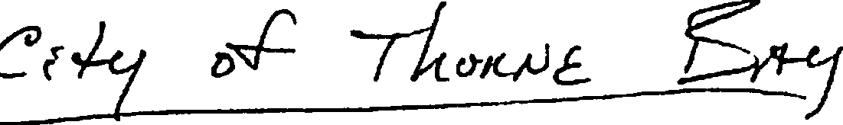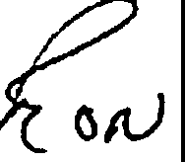

Quatity
10 | 30 amp receptacle | CRL530R
5 | SO amp receptacle | CS8269
4 | 20 amp breaker | QOB120
10 | 30 amp breaker | QOU130
10 | SO amp breaker | QCF2050

10 feet each 10 AWG red, black, white, green

10 feet each 8 AWG red, black, white, green

10 wire ends for 10 AWG 3/8 lug

20 wire ends for 8 AWG 3/8 lug

10 wire ends for 8 AWG spade end (to fit 30 amp receptacle screws)

